# Saving For Retirement

## **The Coffee Can Approach**

Historically it was common for people to sew their life savings into a mattress, or to put it into a coffee can hidden high on a shelf. Every so often there is a news story of some lucky person in Europe digging up a 1500-year-old pottery vase full of Roman coins, which may have been somebody’s unused retirement account at that time. Wikipedia has a list of some interesting examples (<https://en.wikipedia.org/wiki/Hoard>). My wife’s grandfather from Russia told me the story of a large sum of money he hid inside a book but forgot about. By the time he found the money, Russia had experienced high inflation, and declared that the old money was no longer legal tender and so was worth nothing.

It is important to have some cash readily available for emergencies, but hopefully most people reading this book already know that saving cash in a coffee can is not a wise investment. However, it is useful to compare the cash hoarding technique to more modern and effective approaches to saving money.

There are many reasons to save money. Maybe you want to buy a house someday, or take a fun vacation next year, or need a better car. One of the most important reasons for saving money is for your own retirement. It takes some fortitude and foresight to invest for retirement when you are young, but as you will see in the next few pages, the younger you are when you start saving for retirement, the more effective your money will be. If you start saving for retirement in your 20’s, you will end up paying much less money to finance your retirement than if you start after 30. If you are already over 30, the sooner you start saving, the better off you will be.

We can start with some simple assumptions that will make the analysis easier, and later we will change those assumptions one by one to see what effect they have. Let’s say you start saving a portion of your income when you are 20 years old, you retire at 70, and plan to live until 90. So, you will save money for 50 years, then live off the money for 20 years. Further, assume you get paid one time per year some amount called gross income, and when you get paid you put some fraction of your gross income into a coffee can.

We need to define some variables, so the equations don’t get too long, and let’s also give some more or less reasonable numbers.

gI = gross income ($50k/year)  
yS = years saving (50 years)  
yR = years retired (20 years)  
nI = net income (to be calculated)  
sR = savings rate (to be calculated)  
sAR = savings at retirement (to be calculated)  
PMT = gI*sR (your annual payment to your saving account)

The fraction of your gross income that you save is your savings rate, and the money you have left over for day-to-day living is your net income:

$nI = gI – gI*sR$ $nI = gI*(1 – sR)$

Another simplifying assumption is that you never get a raise at work, so you have the same gross income all the years that you work. Hopefully that isn’t true, but later we will look at how increasing wages affect your retirement savings. We will also assume that you don’t pay taxes, and that when you retire, your income will be the same as your net income was when you were working. This last one is perfectly reasonable because if you have lived off your net income all your life, surely you can continue to live off that amount in retirement. So how much money do you need when you retire? Based on the previous equation for net income, you need

$sAR = yR*nI$ $sAR = yR*gI*(1-sR)$

We can also write a different equation for savings at retirement, which is the amount you actually did save:

$sAR = yS*gI*sR$

The first equation is what you need to save, and the second equation is how much you did save. Hopefully these are the same:

$yR*gI*(1-sR) = yS*gI*sR$ $yR*(1-sR) = yS*sR$ $\frac{1}{sR}-1= \frac{yS}{yR}$ $sR=\frac{1}{1+\frac{yS}{yR}}$

So, for the coffee can approach to saving for retirement, you need to save

$sR=\frac{1}{1+\frac{50 years}{20 years}} =28\%$

28% of your gross income! Notice that it doesn’t matter what your gross income is, the percentage saving rate is still the same. That is a lot. If I was making $50k per year, I doubt I could afford to put $14k every year into the coffee can. Figure 1 is a graph showing this scenario. All the graphs in this book are made using Python code, which is available under an open source license at <https://github.com/mmignard>.

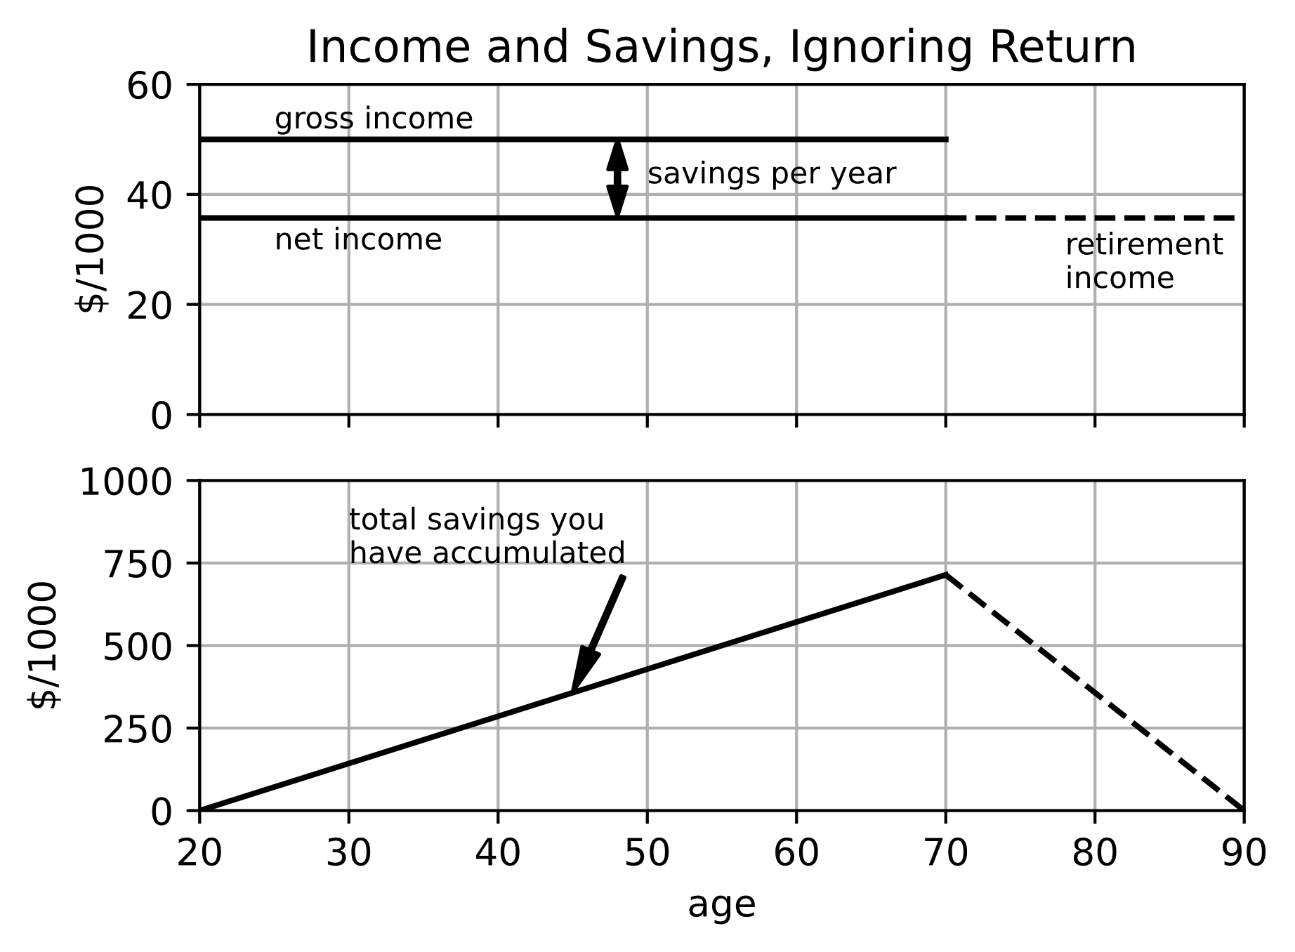

Figure 1, Income and Savings, Ignoring Annual Return

## **Life Is Better with Compounded Returns**

Again, let’s say at the end of each year you put some fraction of your gross income into an account, but now that account pays you a return every year. Your net income is nI=gI*(1-sR), and the amount of money you deposit at the end of each year (your payment or contribution to yourself) is cpmt = sR*gI.

With an account with a rate of return, every year you collect some percentage of the money you have saved. If we call the return “r”, which is maybe r= 5% per year, and if you have savings S in your account, then you will get S*0.05 = S*r in returns each year. Of course, you already had S in your account, so the total amount after the return payment is S+S*r = S*(1+r). At the end of the first year, you will deposit cpmt, but you won’t receive any return until the next year. We can call the amount of money at the end of the first year S0 = cpmt. It is kind of arbitrary if year one has a subscript of zero or one. I have implemented many of these equations in the Python programming language, and it indexes arrays starting at zero, so I have used that convention.

It gets a little more interesting at the end of the second year because then your savings S1 is composed of the new cpmt you will deposit, plus the cpmt from last year, plus the return from last year.

$S_{1}= c_{pmt}+c_{pmt}+c_{pmt}*r$ $S_{1}= c_{pmt}*(1+(1+r))$

Things get even more interesting the third year because you have the new cpmt, plus your previous money, plus the return on it.

$S_{2}= c_{pmt}+c_{pmt}*\{1+(1+r)\}+c_{pmt}*\{1+(1+r)\}*r$ $S_{2}= c_{pmt}*(1+\{1+(1+r)\}+\{1+(1+r)\}*r)$

Look closely at the parts in the curly brackets {1+(1+r)}. How many of them do we have? There is one {} on the left, and there is a second {}*r on the right. So, we have a total of {}*(1+r).

$S_{2}= c_{pmt}*(1+\{1+(1+r)\}*(1+r))$ $S_{2}= c_{pmt}*(1+(1+r)+{(1+r)}^{2})$

At the end of the fourth year, your cumulative savings will be

$S_{3}= c_{pmt}+ c_{pmt}*\{1+(1+r)+{(1+r)}^{2}\}+PMT*\{1+(1+r)+{(1+r)}^{2}\}*r$

As before, there is {} + {}*i = {}*(1+r), although there is more stuff inside the {} now. Making this substitution and multiplying through by the (1+r) gives

$S_{3}= c_{pmt}*(1+(1+r)+{(1+r)}^{2} +{(1+r)}^{3})$

Are you seeing a pattern here? Without going through the derivation, hopefully you can see that at the end of the fifth year, your savings will be :

$S_{4}= c_{pmt}*(1+(1+r)+{(1+r)}^{2} +{(1+r)}^{3}+{(1+r)}^{4})$

What about when you are ready to retire after 50 years? That is a pretty long formula. As you will see shortly, there is a cool trick to simplify it. First, though, this type of equation is called a series, and it has a long and interesting history. Mathematicians have come up with some special shorthand notations for series.

$$S_{n}= c_{pmt}*(1+(1+r)+ … +{(1+r)}^{n-1}+{(1+r)}^{n}) \\ S_{n}=c_{pmt}*\sum_{k=0}^{n}{{(1+r)}^{k}}$$

Notice that anything raised to the 0 power is just 1. The ellipses (…) mean there are some missing terms you have to fill in. The funny symbol ∑ is the Greek capital letter sigma, which is short for sum, and the stuff above and below ∑ indicate you are going to start with k=0, then add terms with k=1, k=2, …, all the way up to k=n. At the end of the 50th year, the last term will be (1+r)50.

This equation is so important in mathematics it has its own name—a partial geometric series. If n was infinity, then it would be called a geometric series, but a geometric series with an infinite number of terms only converges (the sum is less than infinity) if -1 < (1+r) < 1. To simplify the partial geometric series, let’s multiply Sn by (1+r), and then subtract Sn from it. It sounds a little crazy, but something magic happens.

$$(1+r)*S_{n}= (1+r)*c_{pmt}*(1+(1+r)+ … +{(1+r)}^{n-1}-1+{(1+r)}^{n}) \\ (1+r)*S_{n}= c_{pmt}*((1+r)+{(1+r)}^{2}+ … +{(1+r)}^{n}+{(1+r)}^{n+1})$$

If we subtract Sn from this, on the left-hand side we get

$$(1+r)*S_{n} -S_{n}= r*S_{n}$$

But look what happens on the right-hand side. All the terms subtract out except the first and the last:

$$r*S_{n} = c_{pmt}*({\left(1+r\right)}^{n+1}-1)$$

So, we get a much simpler equation:

$$S_{n}=c_{pmt}*\frac{1}{r}*({(1+r)}^{n+1}-1)$$

This equation is also an important one. If you ever borrow money to purchase a car or get a mortgage to purchase a house, this is the equation that the bank will use to calculate your monthly payment. Sn is the amount you borrow, and cpmt is the amount you must pay every month. But for a loan you usually make monthly payments, so “n” is the number of months that you make payments instead of the number of years, and the interest i=(annual interest)/12=r/12 since there are 12 months in a year. This is one of the equations in a group called Time Value of Money (or TVM). See section 4.17 (???) on TVM variations for a home mortgage. While the equations for a loan and for returns on an investment are identical, rate of return and interest are very different things. We will discuss this more in detail in the next section. If you look up TVM equations on the internet, usually they start counting at year one instead of year zero, so the “n+1” exponent becomes just “n”.

There is a tendency to want to read through a book quickly and find the little gems of information it offers. In that mode of thought, deriving equations can seem to be tedious. While I think that the equations derived in this book are useful, the techniques used to start from a concept and end with an equation are as important as the equations themselves. The more effort that a reader expends in understanding where these equations come from, the more prepared that reader will be in the future to set up and solve their own problems.

Remember that cpmt = sR*gI, and as with coffee can savings, we want our savings at the time of retirement to be sufficient to provide us with the net income we have grown accustomed to.

$sAR=yR*gI*(1-sR)$

Now, however, the second equation is different. During all the years you are working and saving you are collecting a rate of return, so your total savings at retirement is:

$$sAR=sR*gI*\frac{1}{r}*({(1+r)}^{yS}-1)$$

We again combine the two equations for sAR and solve for sR:

$$yR*gI*(1-sR)=sR*gI*\frac{1}{r}*({(1+r)}^{yS}-1) \\ \frac{1}{sR}-1=\frac{1}{r*yR}*({(1+r)}^{yS}-1)$$

$$sR=\frac{1}{1+\frac{{(1+r)}^{yS}-1}{r*yR}}$$

What should we use for the return rate, r? In the USA, a standard benchmark is the Dow Jones Industrial Average (DJIA). Over the last 100 years (since 1921), the “average” rate of return of the DJIA has been about 5%. We will talk about what “average” means in the next section. People can argue endlessly about what return they think they can get, but for now let’s just assume it is 5%. Then

$$sR= \frac{1}{1+\frac{{1.05}^{50}-1}{0.05*20}}=8.7\%$$

Wow, what a difference! Instead of saving 28% of your income in a coffee can, you only need to save 8.7% of your income in a low-risk index fund tied to the DJIA. Figure 2 shows the cumulative savings with the rate of return factored in. Compare it to Figure 1.

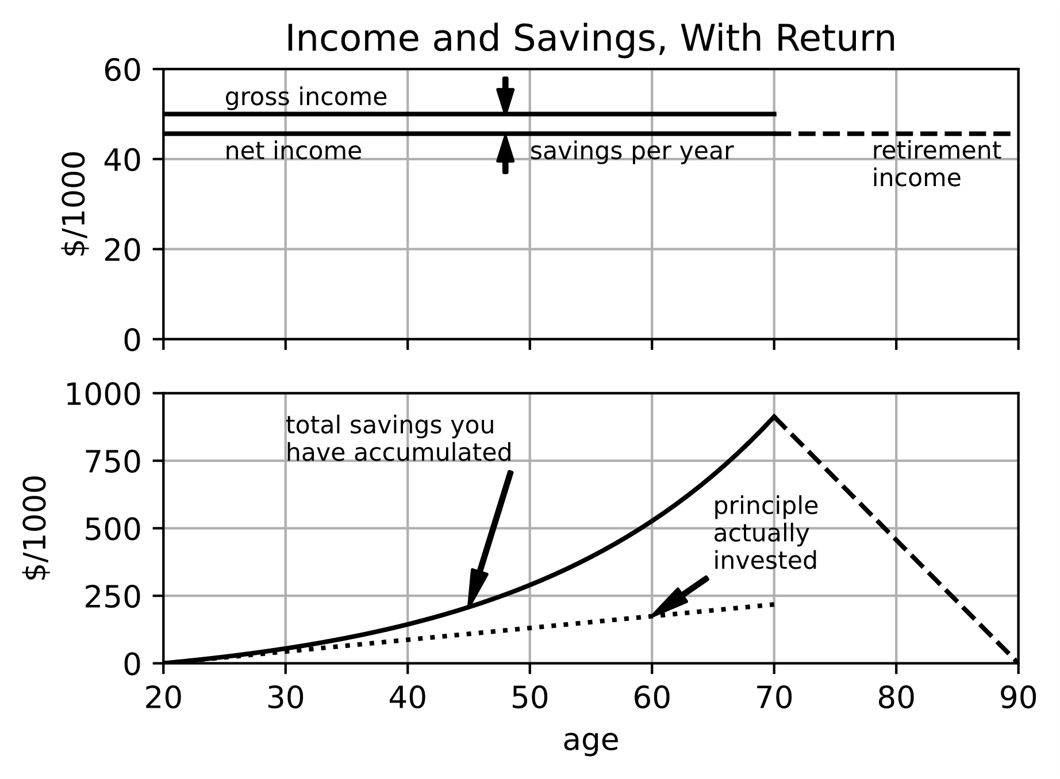

Figure 2, Income and Savings with an Annual Return

Not only is the saving rate lower with a return, but because of the way these two problems were set up, you have a substantially higher income in retirement. Instead of $50k/year*(1-0.28) = $36k/year during retirement, you now have $50k/year*(1-0.087) = $46k/year. This is kind of an artifact because we calculated the required savings rate for retirement income to equal net income during working years. You could change the problem statement to “what savings rate is required to have a fixed income of $40k/year in retirement?” That is a good problem to work through yourself, and when you are done, you can compare your results to Figure 3.

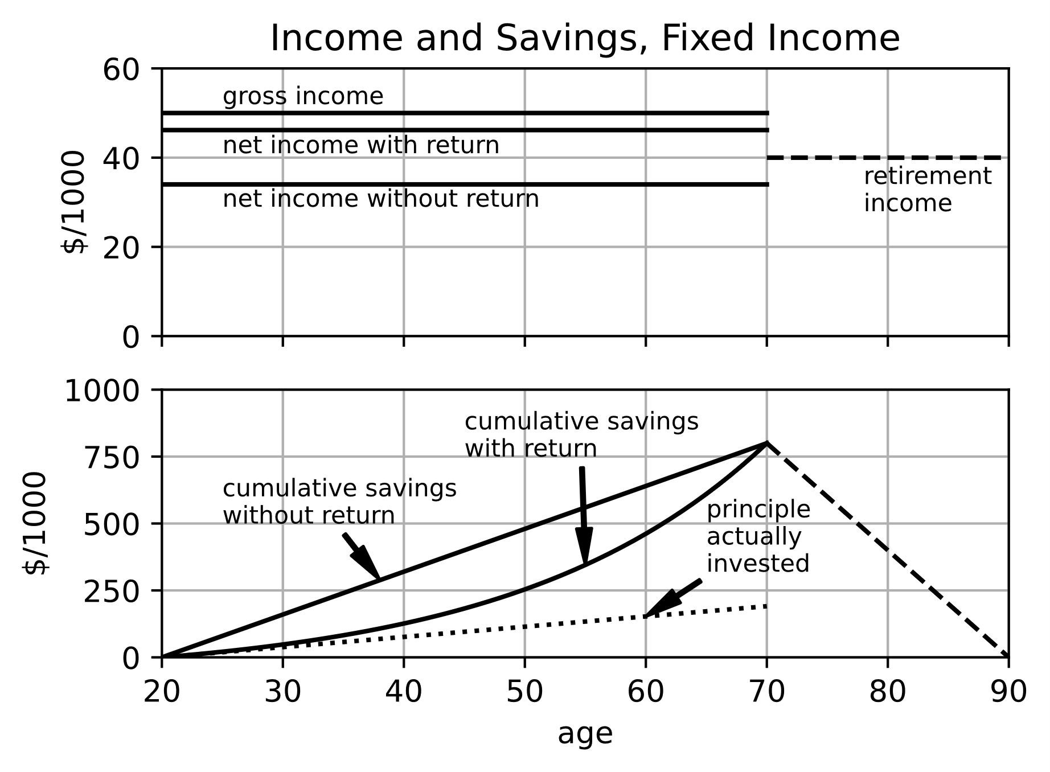

Figure 3, Income and Savings with Fixed Retirement Income, showing that you don’t need to invest nearly as much of your money if you can collect a return on your savings.

In the next sections of this chapter, we will look at some of our assumptions. Maybe you have already been thinking “what about taxes?”, or “won’t my wages increase over time?”. Those are very important considerations. Some things like inflation and living a longer life will mean you need to save more. Other things like higher returns on your investments and social security benefits mean you won’t have to save as much. Going to college might increase your wages, but it could also delay when you start saving for retirement, so you won’t be able to estimate if there is a benefit to college unless you do some calculations. First though, let’s talk about rates of return on investments, and how it differs from interest on a loan.

## **Rate of Return**

I mentioned in the last section that interest is different from rate of return. Interest exists because people or institutions who lend money usually expect to receive something valuable back from the borrower to compensate them during the time that they cannot use their money for other things. But a substantial fraction of the world’s population (Muslims in particular) considers this compensation to be immoral, in a category with stealing. For most of the last 2000 years, Christians also believed charging interest was immoral. In contrast, the return on an investment in stock is essentially sharing in the profit a company makes because it produces something valuable. When investors buy stock in a company, they are purchasing some fraction of that company. The fraction they are purchasing is (number of shares purchased)/(total number of shares in the company). If the company does its job well, the shareholders will be pleased, and the share price will usually increase. If the company performs poorly or the CEO commits fraud, the shareholders will be displeased, and the share price will usually go down.

There are also some practical differences between interest and return. Typically, an interest rate is constant, or at most changes in a defined way on a fixed schedule. For many investments like stocks, you don’t know how much your investment is going to change until after it has already happened. For publicly traded companies, the value of a stock is set by how much investors are willing to pay during an auction that occurs in a place like the New York Stock Exchange. The return rate of stocks can change wildly in just a few minutes.

The return rates of stocks jump around over whatever timescale you want to look at them. See Figure 4. This is a fundamental property of stocks, and correct analyses of stocks must take this property into account.

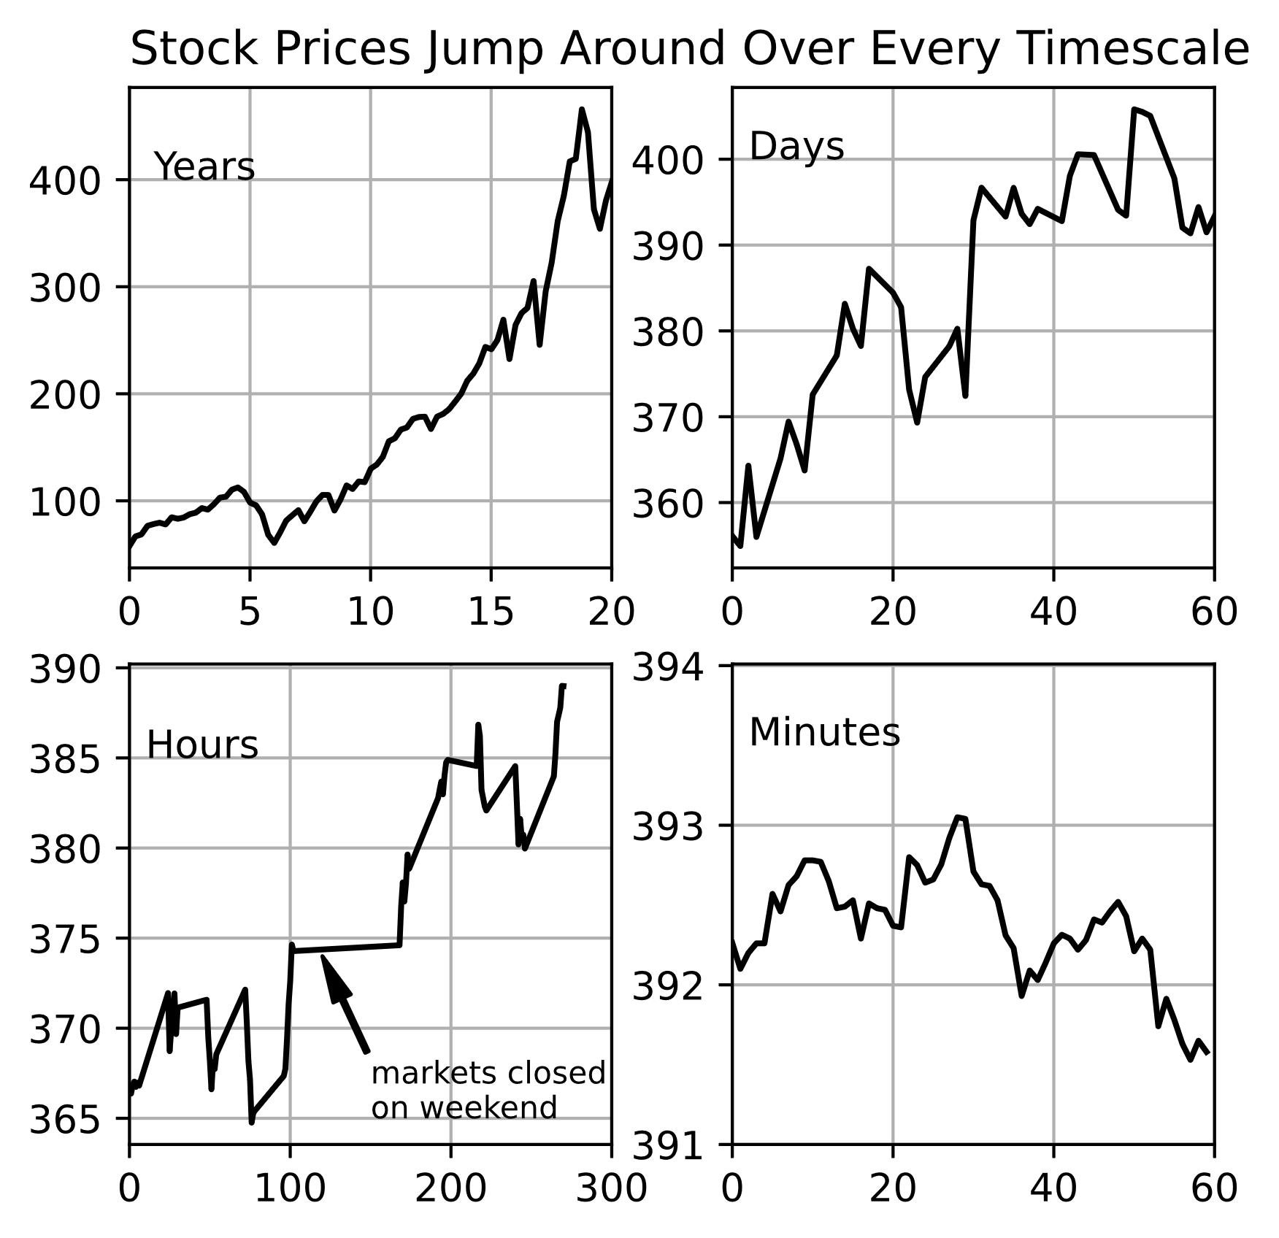

Figure , Stock price changes over different timescales. This example is from the SPY index fund which tracks the S&P 500 set of companies.

In the previous section, we assumed the rate of return is constant, so our analysis would seem to be mistaken. But the equations we came up with are useful, so we would really like to come up with some return rate number that matches the actual jumpy return rates over some time interval. There is such a thing. It is called the Compound Annual Growth Rate, or CAGR. To figure out how to calculate CAGR, let’s start off with the assumption that it exists, and that you bought some stock at a price of P0. Then the amount it would be worth after one year would be:

$$P_{1}=P_{0}+P_{0}*CAGR=P_{0}*(1+CAGR)$$

After the second year, it will be:

$$P_{2}=P_{1}+P_{1}*CAGR=P_{1}*\left(1+CAGR\right) \\ P_{2}=P_{0}*{(1+CAGR)}^{2}$$

See the pattern? After “n” years, the stock will be worth:

$$P_{n}=P_{0}*{(1+CAGR)}^{n}$$

This is a useful formula. It applies to more than stock prices. If you replace P0 with some initial investment clump, and replace CAGR with constant return “r” over “n” periods, this equation says how much money you will have after those “n” periods.

$$S_{n,lump }=c_{lump}*{\left(1+r\right)}^{n}$$

The difference from the formula for Sn in the previous section is that before we assumed we were going to keep adding more money each year, and now we are looking at the case where there is just a single initial lump sum investment.

Getting back to CAGR, now let’s solve for CAGR

$${(1+CAGR)}^{n}=\frac{P_{n}}{P_{0}}$$

$$CAGR= {\left(\frac{P_{n}}{P_{0}}\right)}^{\frac{1}{n}}-1$$

If you bought one share of Tesla stock on the first trading day of 2022 when the price was $312, then the CAGR one year later when the stock price was $122 would be (122/312)1 – 1 = -61%. However, if you bought one share of Tesla stock at the very beginning of 2013 when the price was $2.50, then the CAGR over those 10 years would be (122/2.5)1/10 – 1 = 48%. Both of those numbers are pretty astonishing. Maybe we should look at a stock that is a little less volatile. Johnson & Johnson is the company that makes Band-Aids, Tylenol, Neutrogena beauty products, Acuvue contact lenses, and lots of other useful stuff. Its stock was $178 at the beginning of 2023, $167 at the beginning of 2022, and $54 at the beginning of 2013. So that gives 6.6% CAGR during 2022, and 13% CAGR over the ten years 2013-2023.

The usefulness of CAGR is that it gives us a uniform way of talking about how stock prices change. Johnson & Johnson stock increased by (178-167)/167 = 6.6% during the year of 2022, and it increased by (178-54)/54 = 230% over the decade ending 2022. It is really hard to tell by looking at those two numbers if 2022 was good year or not compared to all the other years in the decade. Using CAGR it is easy to tell that 2022 was not an especially good year for Johnson & Johnson compared to the nine years before it.

It would be ideal to calculate CAGR with some n, P0, and Pn and then apply it to those same years, like we just did. But if you are trying to predict the future, you don’t have those numbers yet, and the best you can do is hope that the past predicts the future.

Notice that variable “n” is in years because that is how CAGR is defined, but “n” does not have to be an integer. The equation works just as well for fractions of years.

Couldn’t we just use the average annual rate of return of a stock? Sure you can, but you will get the wrong answer. To show this, let’s say that we have company “A” that returned 5% every year for 50 years. Of course, its average return was 5%. Then there is company “B” that returned 10% for the first 25 years, and 0% for the second 25 years. Its average return over the 50 years was also 5%. Finally, there is company “C” that returned 0% for the first 25 years, and 10% for the second 25 years, for an average of 5%.

For this kind of problem, we don’t have a nice formula to use, but it is the kind of thing that computers are great at. If you have an array of annual return rates called retArr for a company, you go through that whole array and keep a running sum like this:

sum[0] = 1  
for k in range(retArr.size):  
 sum[k] = 1 + sum[k-1]*(1+retArr[k])

The extra “1+” in the running sum assumes the investor will make a $1 payment every year. If you take the “1+” out, you get the results for a single initial investment of $1 at the beginning (because sum[0]=1). This code was used to create Figure 5 for companies A, B and C with different annual rates of return, but all with 5% average return. The top graph shows three different rates of return. The bottom graph shows how different the results are.

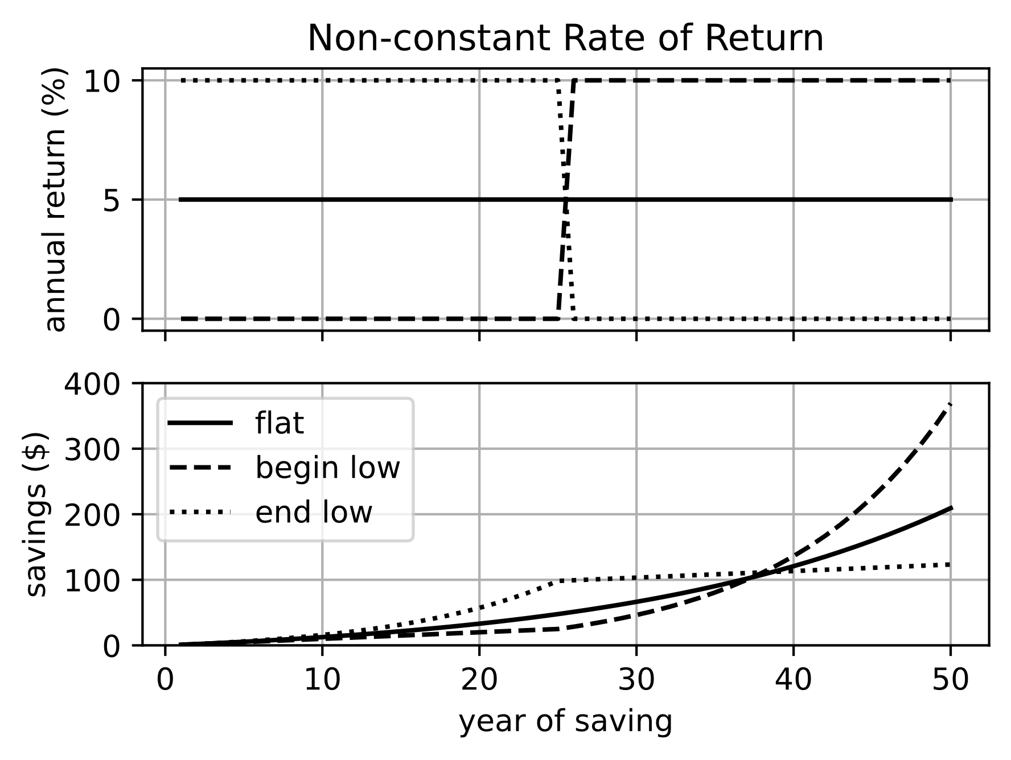

Figure 5, Cumulative investment profiles for three different rates of return that all have the same average rate. This shows that average return rate is a misleading measure.

If you look online at stocks, or hear about them on the radio, you will occasionally hear someone say something like “stocks are up 0.5% today”. If you went back to that same source every day and wrote down how much stocks were up or down for the day, and then you tried to calculate how much the stock market changed over the course of a year, you would get the wrong answer.

Instead, we always track the actual value of a stock or a market. If you go to google.com/finance or finance.yahoo.com, you might see that the Dow Jones is at $34,600. This number has no real meaning by itself. It only has meaning compared to what it was in the past, and what it will be in the future.

Similarly, the Nasdaq might be at $10,500. You cannot make any useful comparisons between the Nasdaq number and the Dow Jones number. You might go to the grocery store and see that apples are $2.00 per pound, and oranges are $1.90 per pound, and it is possible to make a reasonable comparison between the price of these two fruits. With stocks, it is not possible to make any reasonable comparison based on the face value of their stock prices.

You can however say something like the Dow is down (it has decreased in value), and the Nasdaq is up (it has increased in value) compared to what they were previously. If the Nasdaq was $10,200 last month, and it is $10,500 this month, then it has increased in value by (10500-10200)/10200 = 3% during that month. Notice that you normally divide by the older time. This is because we usually talk about time as moving forward. Positive change numbers are increases in value, and negative numbers are decreases in value.

In section 1.2 we derived the formula for the total savings in an account with regular payments and constant rate of return (or CAGR). Earlier in this current section we derived the total savings in an account that also had constant return but was just funded with an initial amount. How do these two scenarios compare? The case of regular payments describes a person who started with very little money, but diligently put some money away every month. The other case perhaps describes someone who was lucky enough win the lottery when they were young and smartly decided to invest it, but then didn’t keep adding to their investment. Who do you think will have more money in the long run? Think in terms of the fable about the rabbit and the turtle who run a race and the rabbit falls asleep in the middle of the race while the turtle keeps plodding along. The investor who makes diligent regular investments will often win in the long term. Figure 6 shows the results for some reasonable investment numbers.

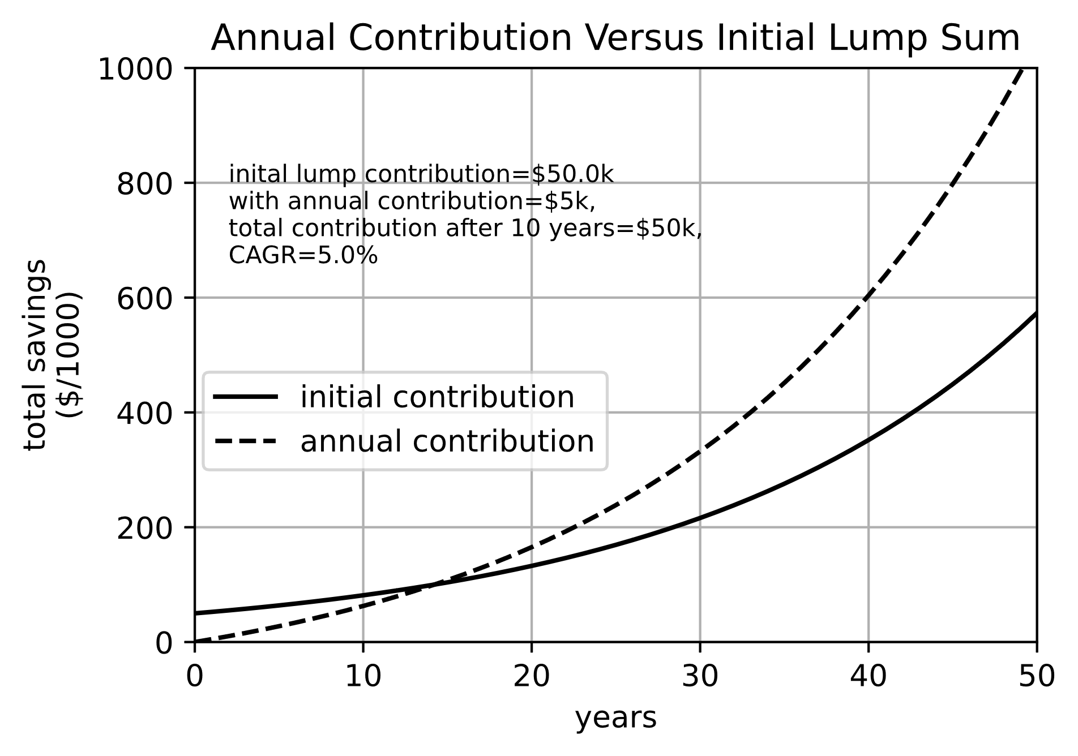

Figure , Comparison of rabbit approach to investing and the turtle approach.

Most people spell out the letters in CAGR, similar to FBI or IRS, but I have heard people say it as a word, like “Kayger”. We do that for other acronyms like NASA or SCUBA, so it sounds reasonable to me.

Here are the key equations derived so far:

$$\begin{aligned}S_{n,pmt}=c_{pmt}*\frac{1}{r}*\left({\left(1+r\right)}^{n+1}-1\right) \# REF _Ref125178421 \backslash r \backslash h 1.3.1\end{aligned} \\ \begin{aligned}S_{n,lump }=c_{lump}*{\left(1+r\right)}^{n}\# REF _Ref125178421 \backslash r \backslash h 1.3.2\end{aligned}$$

Where “c” is the investment you make into your investment account, and Sn is the amount in that account at the end of “n” years. If return “r” is not constant, then use CAGR instead:

$$\begin{aligned}CAGR= {\left(\frac{P_{n}}{P_{0}}\right)}^{\frac{1}{n}}-1 \# REF _Ref125178421 \backslash r \backslash h 1.3.3\end{aligned}$$

Where “Pn” is the price of a stock “n” years after it was at price P0.

## **Inflation**

When I was a kid gasoline went over $1 per gallon. That was a problem for gas stations because the pumps only had three digits, so they could only charge up $0.999 cents per gallon. It is kind of bizarre that the cost of most things you purchase are rounded to the nearest cent, so you would never see a price in the store of $2.591 per pound of apples. For gasoline though, they still have that third decimal place in the price per gallon. I’m sure it is left over from when gasoline was $0.05 per gallon, and that extra decimal point was important. When gasoline went over $1 per gallon, the pumps couldn’t handle a number that large. The temporary solution was to subtract $1 from the price per gallon and put that into the pump. You would see something like $0.15/gallon on the pump, but everyone knew that once you got inside the store to pay, the attendant would charge you $1.15. Over the next few years all those pumps were replaced by newer ones that had a place for the number of dollars in addition to the number of cents. As we will see in a little bit, if the rate of inflation we experienced in 2022 continues, the price per gallon of gasoline will exceed $10 in only eight years, and somebody will have to go around and replace all the thousands of gas pumps in the US again. Hopefully inflation will calm down before too long and return to its normal effective rate of under 3%. If that happens, then it will be more like 25 years before all the gas pumps have to be replaced.

Most people reading this book will have noticed the effects of inflation. In a few years, the money you have now will not purchase as much as it will today. This seems like a bad thing, but surprisingly it is healthy for the economy to keep inflation near a small positive value, around 3%. If inflation becomes negative (which is called deflation), then people realize their money will be worth more in the future, so they will put off buying things they might want or need. When people put off buying things, that hurts the economy. Companies see that people are buying less, so they produce less, and then they don’t need quite so many employees, so they lay workers off. It is better to avoid deflation, and governments have generally gotten good at doing things like adjusting interest rates to keep inflation at a small positive value.

On the other end of the spectrum, if inflation increases at a high rate in a country, people will often start to use a more stable foreign currency. That makes the local currency less valuable, which tends to push inflation higher. This, combined with government mismanagement like printing extra money to cover its costs (often related to a war it cannot afford), can lead to “hyperinflation” such as is happening in Venezuela, and has happened in several of the countries under the Soviet sphere of influence after the breakup of the USSR. The Wikipedia article on hyperinflation lists many examples of countries that have experienced hyperinflation in history.

Inflation is harder to track than stock prices. On the internet it is easy to find stock prices for public companies, or many bond prices, or options prices. These are all publicly traded investment instruments, the prices are set by their markets, and the prices are published. Inflation tracks the change in value of all the things that people buy in the course of their normal lives. One would think it should be easy to track those prices, but it is surprisingly difficult because there are so many different items that people need or are interested in. Because of this difficulty, and because it is such an important metric, most modern governments have a department devoted to tracking the prices of goods. In the US, it is called the Bureau of Labor Statistics, and its website is bls.gov. On this website you can find a wealth of data on historical prices for the goods we consumers depend on. Figure *7* shows the main metric that the US BLS tracks, called the Consumer Price Index (CPI). I downloaded this data from bls.gov. The upper half of the plot is the CPI, which works a little like a stock price. It shows the price of typical consumer goods relative to what those prices were some time in history. This index is arbitrarily defined to be 100 in the year 1983. Remember that the actual price of a stock is unimportant, it is only how the price changes that matters. Similarly, the actual value of the CPI is unimportant. We are only interested in how it changes over time. The lower half Figure 7 of is the year-to-year change in the CPI, which we usually refer to as inflation. The yearly inflation is therefore (CPIn- CPIn-1)/CPIn-1 Where “n” refers to the CPI in the year you are interested in, and “n-1” refers to the previous year.

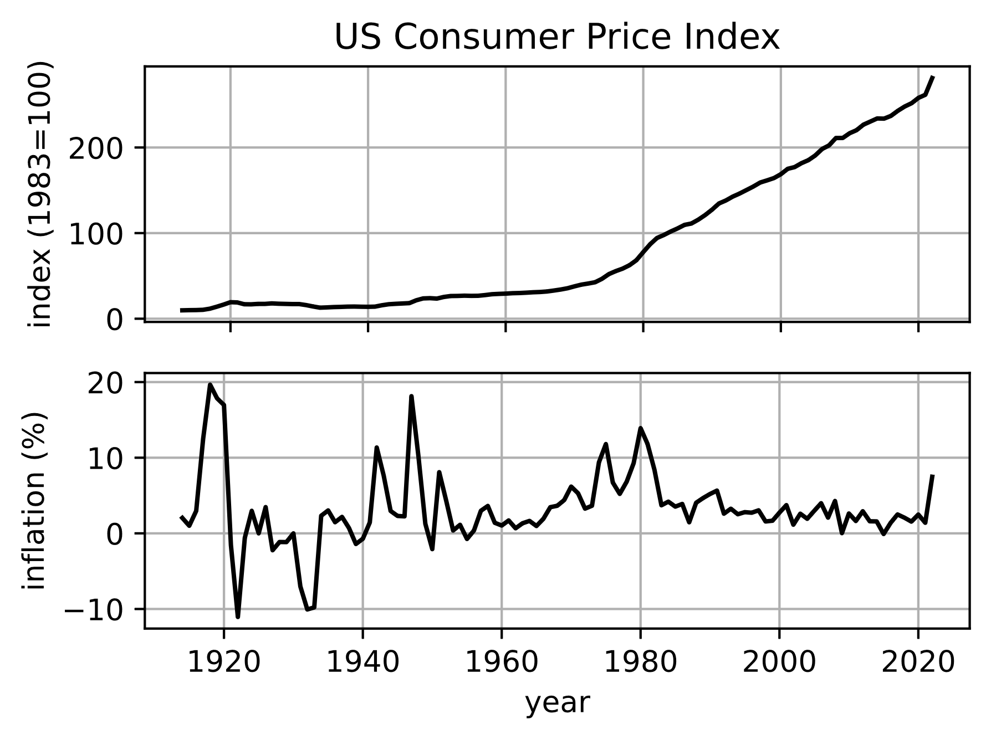

Figure 7, Consumer Price Index and the amount the CPI changes each year, which is one measure of inflation.

The CPI is supposed to reflect the prices paid and the goods required by a typical citizen in the US. Clearly it does not perfectly fit every person in the US. A retiree living in Florida needs somewhat different items and pays different amounts for them than a college student living in California. The CPI is compiled from several different elements, some of which are shown in Figure 8. Notice that the cost of medical care has increased much faster than cost of housing, which has in turn increased faster than food. The people at the Bureau of Labor Statistics combine all these individual indicators (and others that are not shown here) into a single index. They also track prices in several different parts of the country and weight the regional factors into the CPI according to how many people live in each region. It is a lot of work, and it is useful information, but keep in mind that it is intended to apply to a typical person in the US, and not to any particular person.

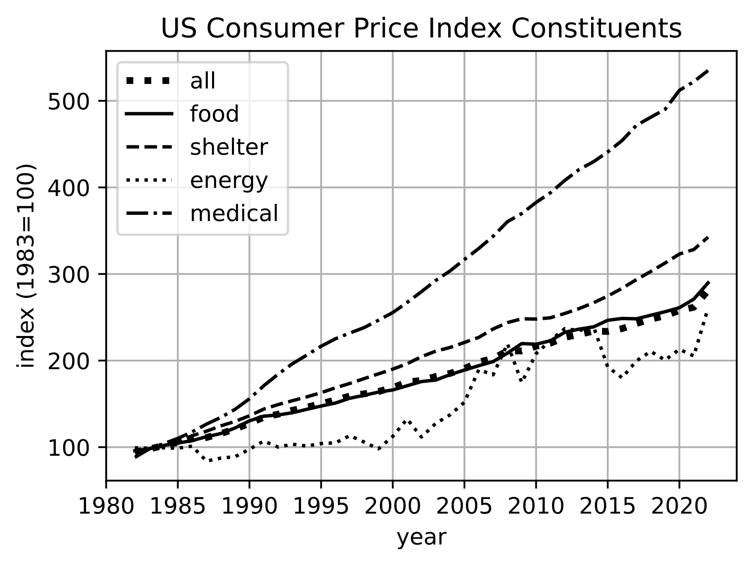

Figure 8, Index of some of the elements that go into the Consumer Price Index.

So how do we apply the effects of inflation to our calculations on savings and investments? Let’s start off by assuming on some date you purchased Ns shares of stock at a price of P0. The total value of those shares on the purchase date was:

$$V_{0}=N_{s}*P_{0}$$

At some later date, when the price has increased to Pn, the value will be

$$V_{n}=N_{s}*P_{n}$$

If we solve for Ns in the two equations, and set them equal, we get:

$$\frac{V_{n}}{P_{n}}=\frac{V_{0}}{P_{0}}$$

Solving for Vn gives

$$V_{n}=V_{0}*\frac{P_{n}}{P_{0}}$$

The CPI is an index that works a lot like a stock price, with a twist. The CPI is a generally upward trending curve, but you know that if you had some amount of money M several years ago, it is now worth less. Let’s call the value of M in today’s money MinfAdj. Then we can write:

$$M_{infAdj}=M*\frac{{CPI}_{0}}{{CPI}_{n}}$$

The inflation adjusted value of MinfAdj is smaller than the original M because CPI0<CPIn (except for a long time ago when deflation was more common). That means you can’t buy as much with it today. We can do a similar correction for the previous equation for Vn to get an inflation adjusted number for the value today in today’s money:

$$V_{n,infAdj}=V_{0}*\frac{P_{n}}{P_{0}}*\frac{{CPI}_{0}}{{CPI}_{n}}$$

$$V_{n,infAdj}=V_{0}*\left(\frac{{P_{n}}/{P_{0}}}{{{CPI}_{n}}/{{CPI}_{0}}}\right)$$

This is the fundamental way to correct for inflation. Sometimes however it is useful to think about return rates on an investment. If there was a change from P0 to Pn in a stock price over some period of time, then the rate of return over that time was:

$$returnRate=\frac{P_{n}-P_{0}}{P_{0}}$$

$$returnRate=\frac{P_{n}}{P_{0}}-1$$

$$\frac{P_{n}}{P_{0}}=1+returnRate$$

We can substitute this back into the previous equation for Vn,infAdj and get:

$$V_{n,infAdj}=V_{0}*\left(\frac{1+returnRate}{{{CPI}_{n}}/{{CPI}_{0}}}\right)$$

Similarly, we can find that

$$\frac{{CPI}_{n}}{{CPI}_{0}}=1+inflationRate$$

And substituting that into the previous equation gives:

$$V_{n,infAdj}=V_{0}*\left(\frac{1+returnRate}{1+inflationRate}\right)$$

This gives the inflation adjusted value you would have after the length of time over which return rate and inflation rate apply. What if you wanted to know the rate by which your initial investment of V0 grew over that time? That would be:

$$inflationAdjustedGrowthRate=\frac{V_{n,infAdj}-V_{0}}{V_{0}}=\frac{V_{n,infAdj}}{V_{0}}-1$$

$$inflationAdjustedGrowthRate=\left(\frac{1+returnRate}{1+inflationRate}\right)-1$$

Notice that the return rate and inflation rate must both be over the same length of time. It would not make sense to use a return rate calculated over five years, but an inflation rate calculated over one year. It would be useful to have effective annualized rates that we can use for any other amounts of time to compare the effects of different strategies over various time scales. We already introduced the concept of CAGR, which is exactly that for return rates. Recall that in the last section we came up with the following formula involving CAGR:

$${(1+CAGR)}^{n}=\frac{P_{n}}{P_{0}}$$

Let’s make a similar effective annualized rate for inflation, and call it CAIR for Compound Annual Inflation Rate:

$${(1+CAIR)}^{n}=\frac{{CPI}_{n}}{{CPI}_{0}}$$

$$CAIR= {\left(\frac{{CPI}_{n}}{{CPI}_{0}}\right)}^{\frac{1}{n}}-1$$

Then the inflation adjusted growth rate of an investment account becomes:

$$inflationAdjustedGrowthRate=\frac{{(1+CAGR)}^{n}}{{(1+CAIR)}^{n}}-1$$

You might even go so far as to define an inflation adjusted effective annual growth rate of an account. We can call it IAAGR.

$${(1+IAAGR)}^{n}=\frac{V_{n,infAdj}}{V_{0}}$$

$$IAAGR= {\left(\frac{V_{n,infAdj}}{V_{0}}\right)}^{\frac{1}{n}}-1$$

Recall that

$$\frac{V_{n,infAdj}}{V_{0}}=\left(\frac{{P_{n}}/{P_{0}}}{{{CPI}_{n}}/{{CPI}_{0}}}\right)=\frac{{(1+CAGR)}^{n}}{{(1+CAIR)}^{n}}$$

$$IAAGR={\left(\frac{{\left(1+CAGR\right)}^{n}}{{\left(1+CAIR\right)}^{n}}\right)}^{1/n}-1$$

$$IAAGR= \frac{1+CAGR}{1+CAIR}-1$$

This is interesting. IAAGR is already a compound annual rate because the two variables that influence it are also compound annual rates. Let’s rearrange terms a little.

$$IAAGR= \frac{\left(1+CAGR\right)-\left(1+CAIR\right)}{1+CAIR}=\frac{CAGR-CAIR}{1+CAIR}$$

IAAGR is useful because now we want to consider the effects of inflation on periodic contributions to an investment account, instead of just one big investment at the beginning. But we actually already have it. We just substitute IAAGR into equation 1.3.1:

$$S_{n,pmt}=c_{pmt}*\frac{1}{IAAGR}*\left({\left(1+IAAGR\right)}^{n+1}-1\right)$$

$$S_{n,pmt}=c_{pmt}*\frac{1+CAIR}{CAGR-CAIR}*\left({\left(\frac{1+CAGR}{1+CAIR}\right)}^{n+1}-1\right)$$

Also we will compare that to the case with a single investment that is made at the beginning.

$$S_{n,lump}=c_{lump}*{\left(\frac{1+CAGR}{1+CAIR}\right)}^{n}$$

.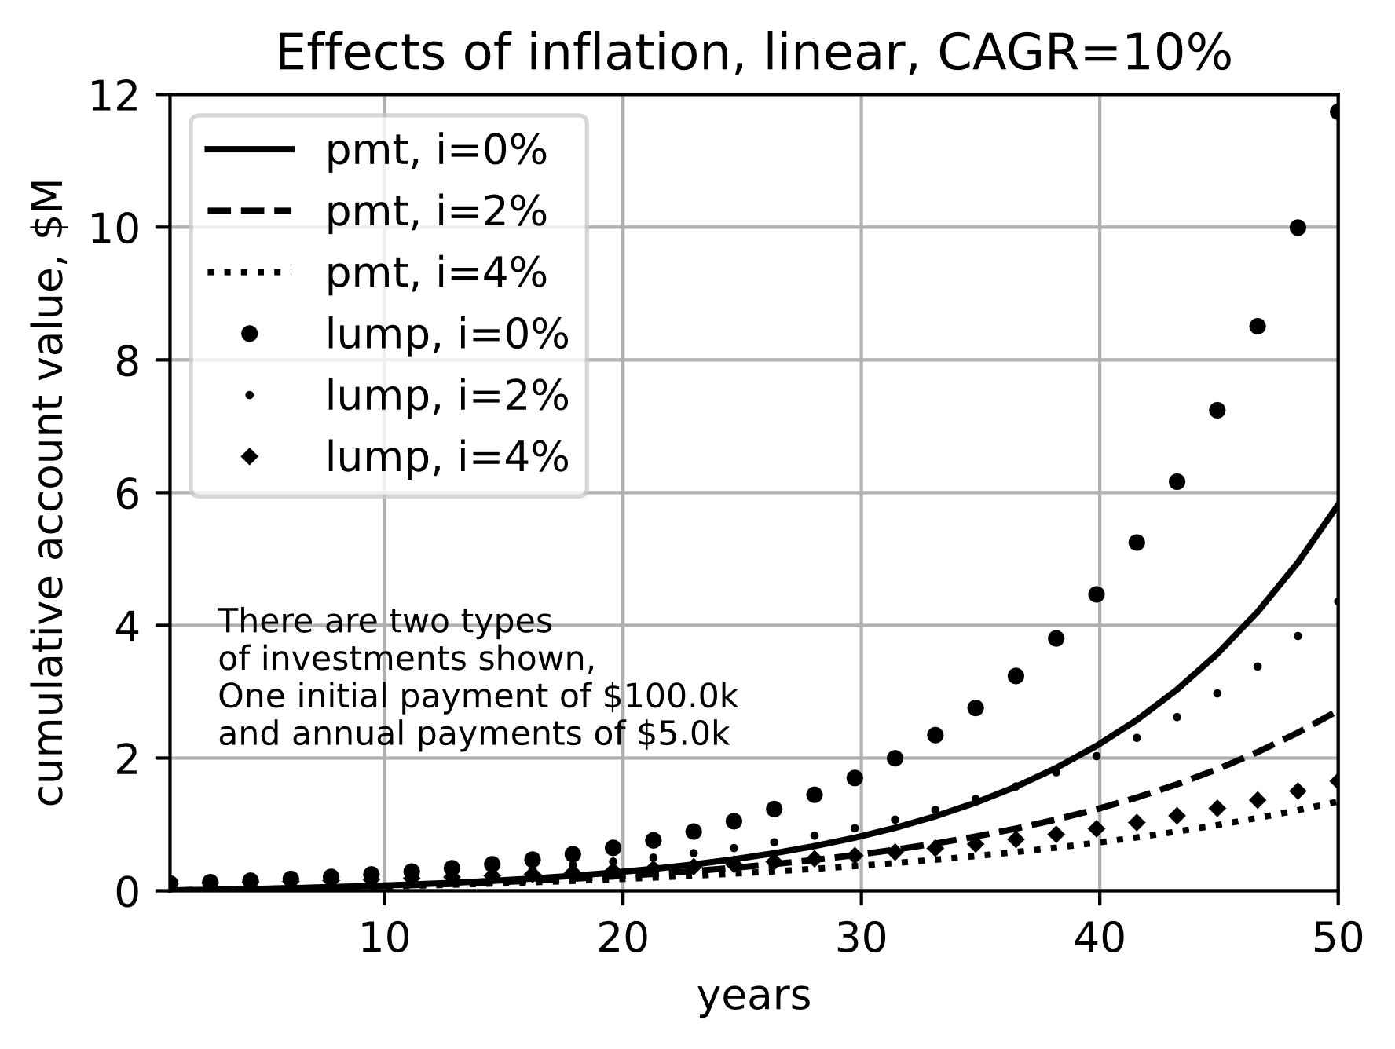

Figure 9, Effects of inflation on an investment, linear scale

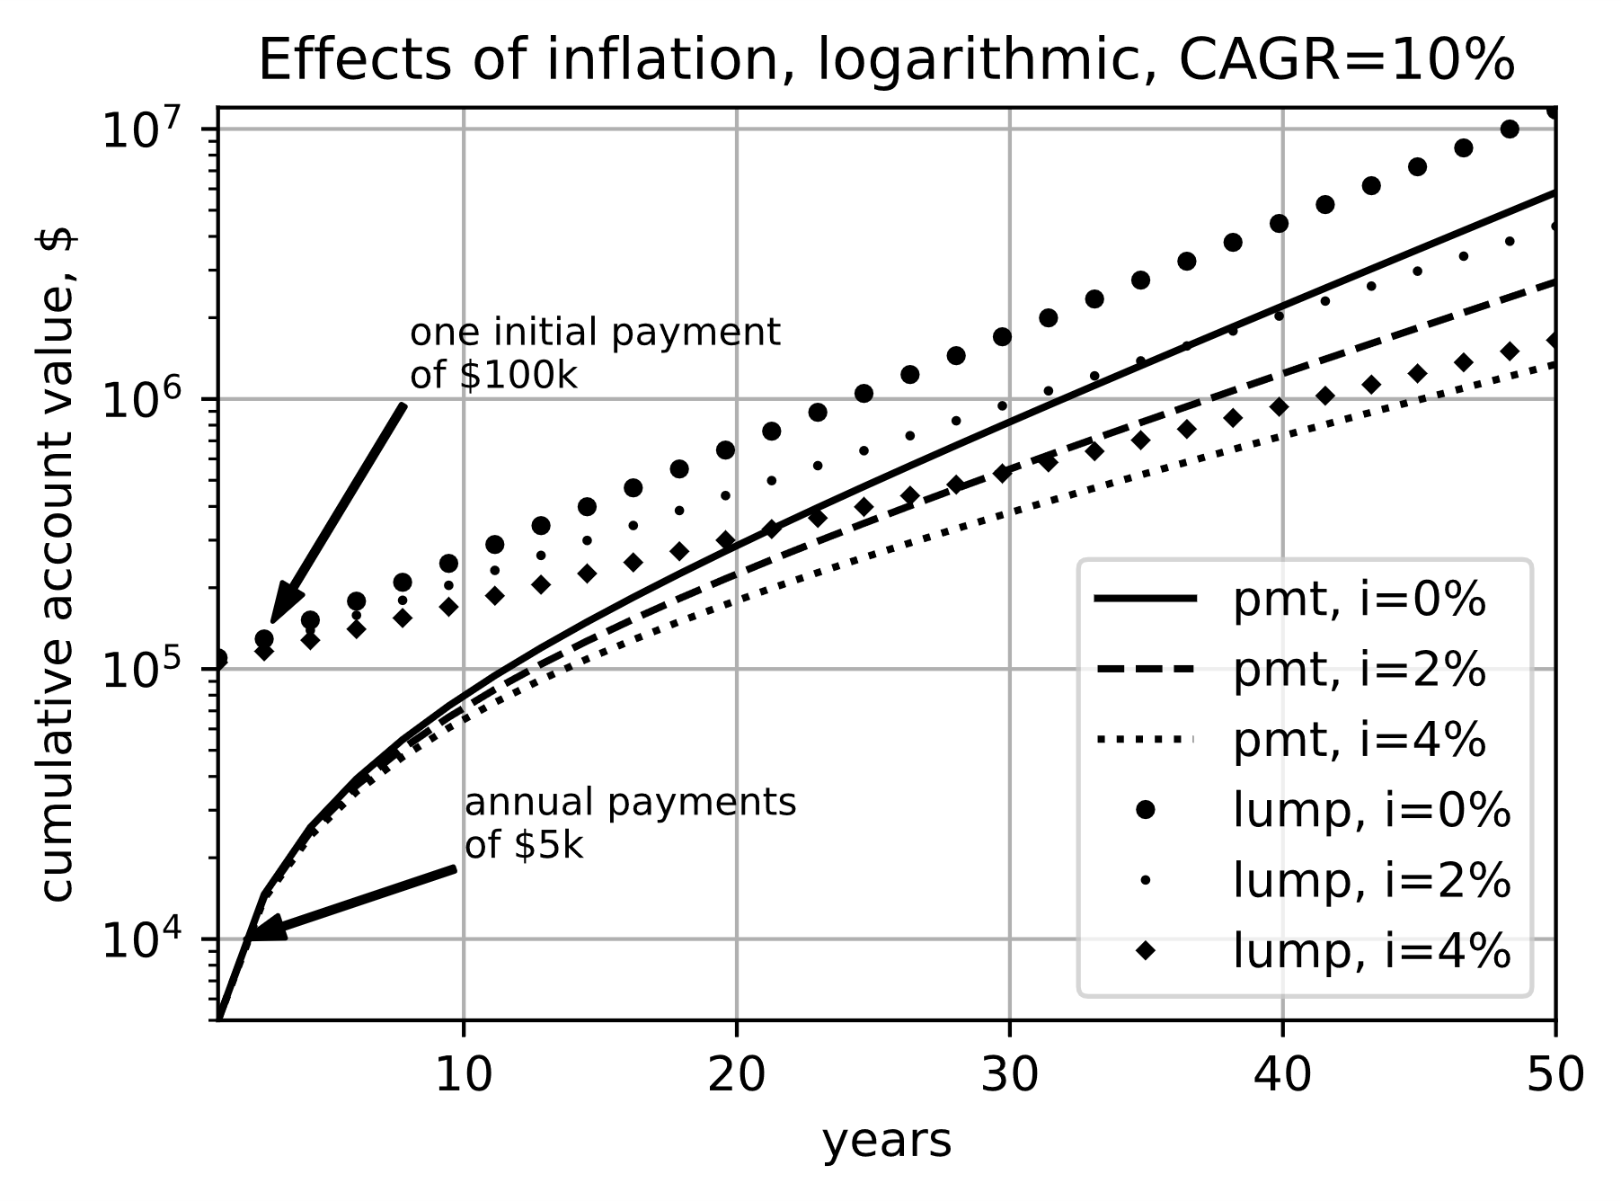

Figure 10, Effects of inflation on an investment, logarithmic scale

Calculating (1+r)/(1+i) is hard to do in your head. It is much easier to just subtract the inflation rate from the return rate. It does not give exactly the right number, but it is fairly close over timescales than an investor is probably most concerned with.

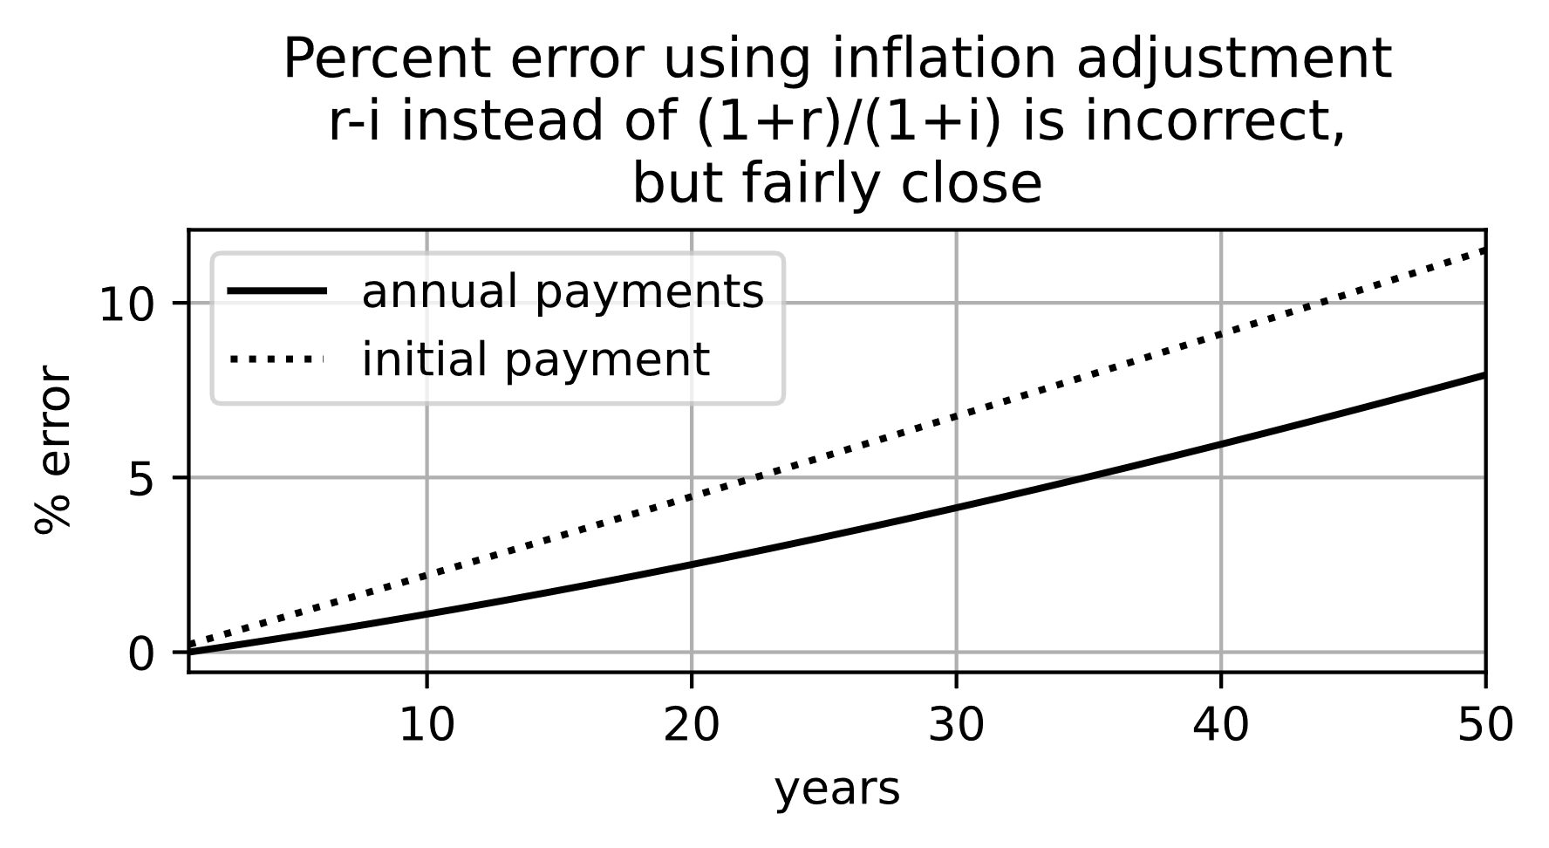

Figure 11, Error due to simplified return adjustment

Calculate when gasoline pumps need another digit (???).

## **How large a nest egg is necessary?**

How much money do you need to retire comfortably with a secure financial future? Unfortunately, this is not an easy thing to answer because so many things that are unknowable. The main one is how long you will live. The longer you live, the more money you need.

The simplest way to calculate how much you need is to assume you have a account with some money, and every year (or every month), you draw the same amount out of it to pay for living expenses. If the value of your savings at the time of retirement is vR0, and every year you withdraw “w” from it, then “n” years after retirement you will have vRn = vR0-n*w. This is a fairly simple equation, but it has several variables in it, and it is hard to grasp how they all interact. If we rearrange the equation an plot a graph, it may make it clearer. To goal is to still have some money (or no less than $0) at the end of your life. So right away we can set vRn=0. Then vR0=n*w and after some rearranging w/vR0 = 1/n. The ratio w/vR0 tells what percentage of the original savings can be withdrawn each year so that at the end of “n” years the saving is zero. Figure 12 is a plot of 1/n. It shows the maximum percentage of savings that can be withdrawn. For instance, if you will retire at age 70, and need an income until 90, that is 20 years. Looking at the figure, 20 years drawing retirement income from savings means you can draw up to 5% every year. If you started with a million dollars, that means your annual income could be 0.05*$1000k = $50k. If you will draw retirement income for 30 years, then the maximum you can withdraw every year is 3.3%, or $33k per year from a $1M savings. It would be hard to save a million dollars just by putting money in a coffee can. But as we’ve seen, compounded return works like magic, and a diligent investor should be able to save this much over a reasonably long career.

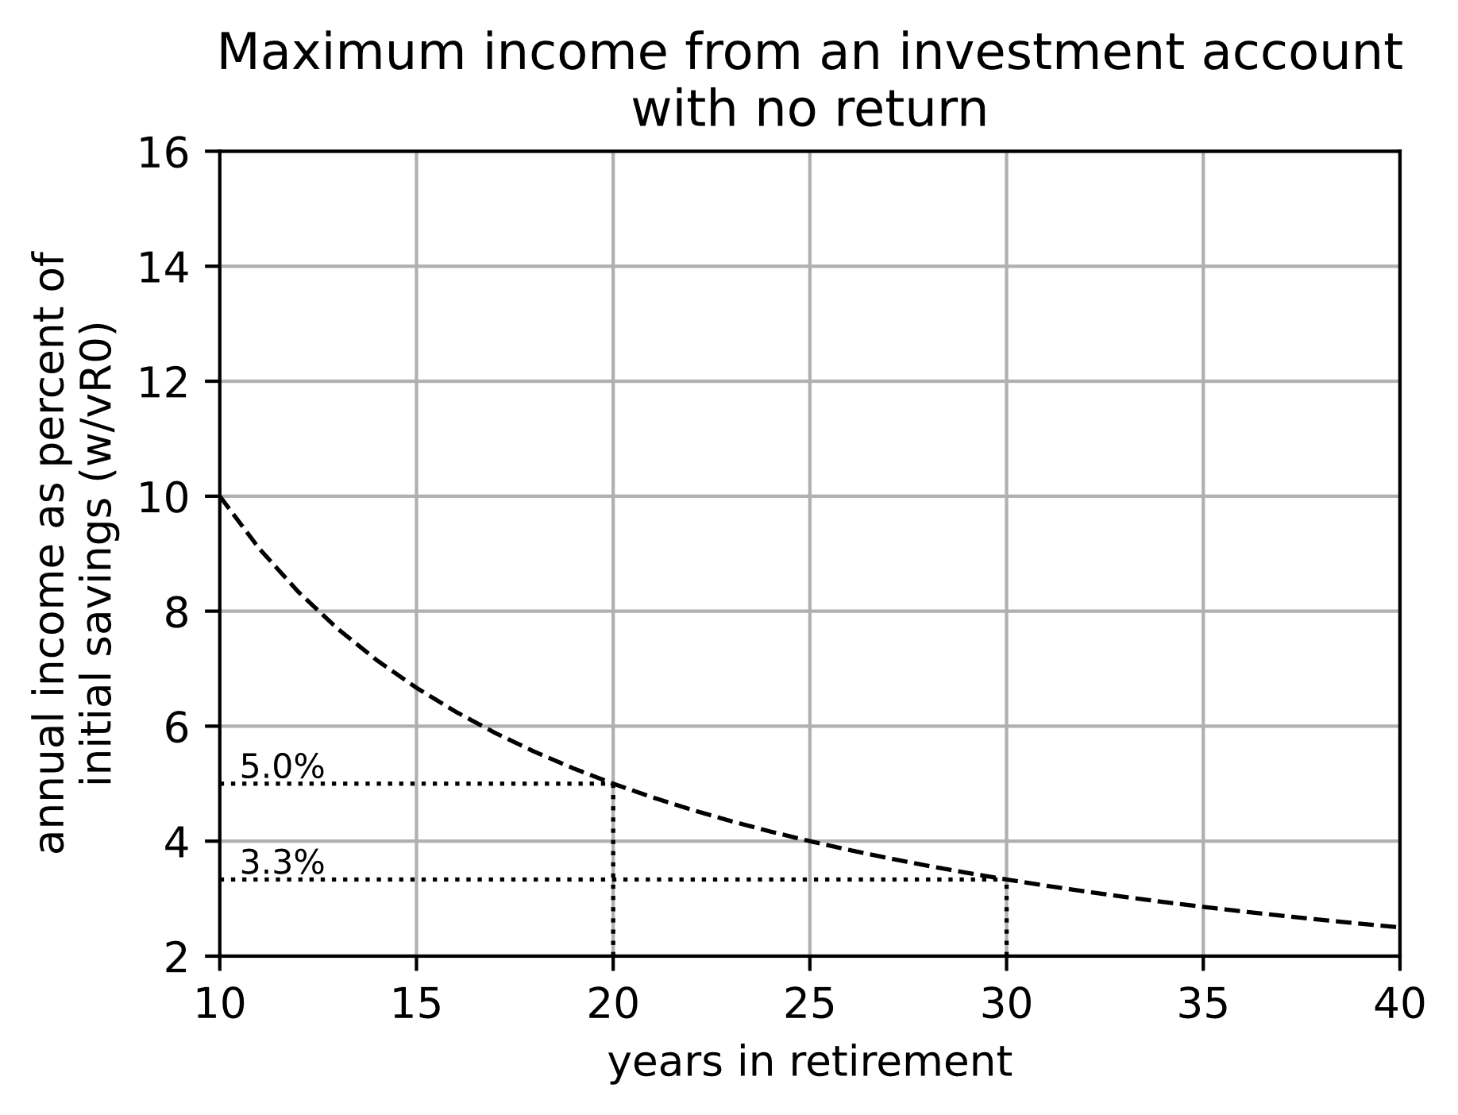

Figure 12, Maximum income from an investment account with no return

Compounded returns work well while saving during a career, and they also work well during retirement. There is caveat, though. While working and saving, it is perfectly reasonable to invest in riskier investments that likely pay higher returns in the long term. But during retirement most people would prefer to have safer lower risk investments that they can count on so if the market goes through a downturn, they do not have to scrimp and worry about finances. That usually means the returns on investments during retirement will have lower returns.

To enhance Figure 12 to include the effects of investment returns, write equations for how the amount savings changes over the years. At the time of retirement, the value savings is vR0. In the next year, the sum will acquire some return, and some money will be withdrawn:

$${vR}_{1}={vR}_{0}*\left(1+r\right)-w$$

At the end of the second year, the amount left in the account will be:

$${vR}_{2}={vR}_{1}*\left(1+r\right)-w$$

$${vR}_{2}=\left[{vR}_{0}*\left(1+r\right)-w\right]*\left(1+r\right)-w$$

$${vR}_{2}= {vR}_{0}*{\left(1+r\right)}^{2}-w*(\left(1+r\right)+1)$$

At the end of the third year:

$${vR}_{3}={vR}_{2}*\left(1+r\right)-w$$

$${vR}_{3}=\left[{vR}_{0}*{\left(1+r\right)}^{3}-w*(\left(1+r\right)+1)\right]*\left(1+r\right)-w$$

$${vR}_{3}= {vR}_{0}*{\left(1+r\right)}^{3}-w*({\left(1+r\right)}^{2}+\left(1+r\right)+1)$$

Is this looking familiar? The first term on the right is the same as simple compounding from section 1.3, and the second term is almost identical to the Time Value of Money equation from 1.2. The amount left in the account after n years is:

$${vR}_{n}= {vR}_{0}*{\left(1+r\right)}^{n}-w*({\left(1+r\right)}^{n-1}+\left(1+r\right)+…+\left(1+r\right)+1)$$

The factor “w” is multiplied by a partial geometric series. Let’s call the series “x”, then

$$\left(1+r\right)*x-x=r*x$$

*r*x = ${\left(1+r\right)}^{n}-1$*

*x $=\frac{1}{r}*\left[{\left(1+r\right)}^{n}-1\right]$*

So,

$${vR}_{n}= {vR}_{0}*{\left(1+r\right)}^{n}-\frac{w}{r}*\left[{\left(1+r\right)}^{n}-1\right]$$

In some year vRn equals 0, and then:

$${vR}_{0}*{\left(1+r\right)}^{n}=\frac{w}{r}*\left[{\left(1+r\right)}^{n}-1\right]$$

$${w/vR}_{0}=\frac{r*{\left(1+r\right)}^{n}}{{\left(1+r\right)}^{n}-1}$$

This tells us what fraction of our savings we can withdraw every year assuming we know ahead of time how many years we need to collect money, and what the rate of return is. Let’s extend this equation a little to include inflation. Recall from Section 1.4 that we have some equations for inflation adjusted effective annual growth rate (IAAGR)

$$1+IAAGR= \frac{1+CAGR}{1+CAIR}$$

$$IAAGR= \frac{CAGR-CAIR}{1+CAIR}$$

We can replace “r” with IAAGR everywhere in the equation for w/vR0:

$${w/vR}_{0}=\frac{CAGR-CAIR}{1+CAIR}*\frac{{\left(\frac{1+CAGR}{1+CAIR}\right)}^{n}}{{\left(\frac{1+CAGR}{1+CAIR}\right)}^{n}-1}$$

If we keep in mind the real meanings of CAGR and CAIR, we can just replace them with “r” and “i” to make the equation smaller. CAGR is a made up number that says what constant annual rate of return gives the same return as an investment did over some other period of time. In real life, the actual annual return rate probably varied quite a bit, but CAGR is constant. Similarly, CAIR is a made up number that says what constant annual inflation rate matches what was seen over some period of time. Here is the simpler equation. Notice if inflation is zero, then the equation is identical to the one we started with.

$${w/vR}_{0}=\frac{r-i}{1+i}*\frac{{\left(\frac{1+r}{1+i}\right)}^{n}}{{\left(\frac{1+r}{1+i}\right)}^{n}-1}$$

Figure 13 is plot of this equation over several years for some selected return and inflation rates. The bottom dashed curve is 1/n as plotted in the previous Figure 12. Notice the r & i equation for w/vR0 does not work when both r & i are zero. It evaluates as 0/0. It is possible, though, to put very small values in for r & i using the computer, and then it works out to essentially the same as 1/n. The figure shows that the maximum income over 20 years increases from 5% with no return to 10.5% with a 10% return, but then it decreases to about 8.5% with 3% inflation. With an initial investment of $1M, the income is $85k per year, which is a pretty good income for retirement in most areas of the US. That is assuming 10% returns year after, that inflation stays under 3%, and you count on only 20 years of retirement before you no longer require income.

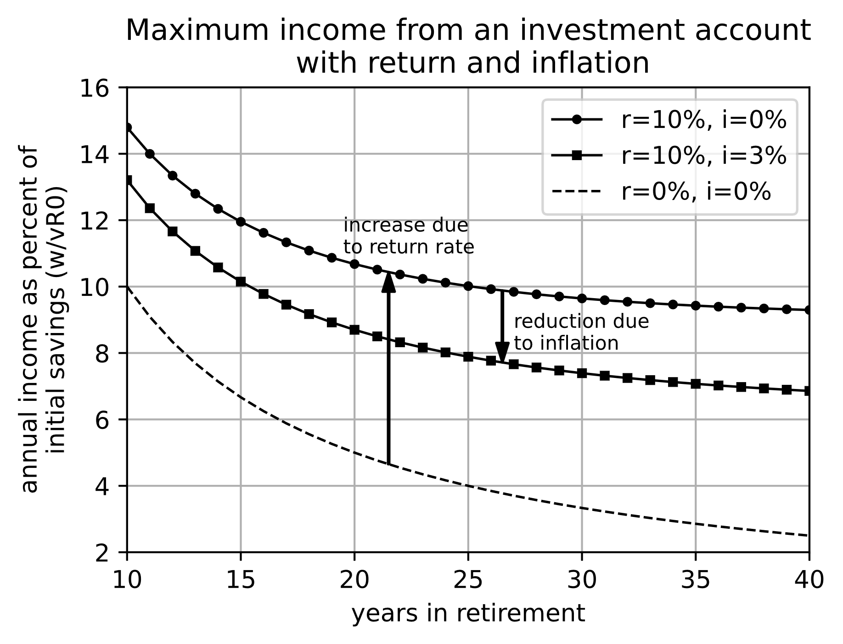

Figure 13, Maximum income from an investment account with return on investment but also inflation

Figure 14 is probably a more realistic 5% return rate during retirement. In this case, for a $1M initial savings, the income is $60k for 20 years of retirement, and $43k for 30 years.

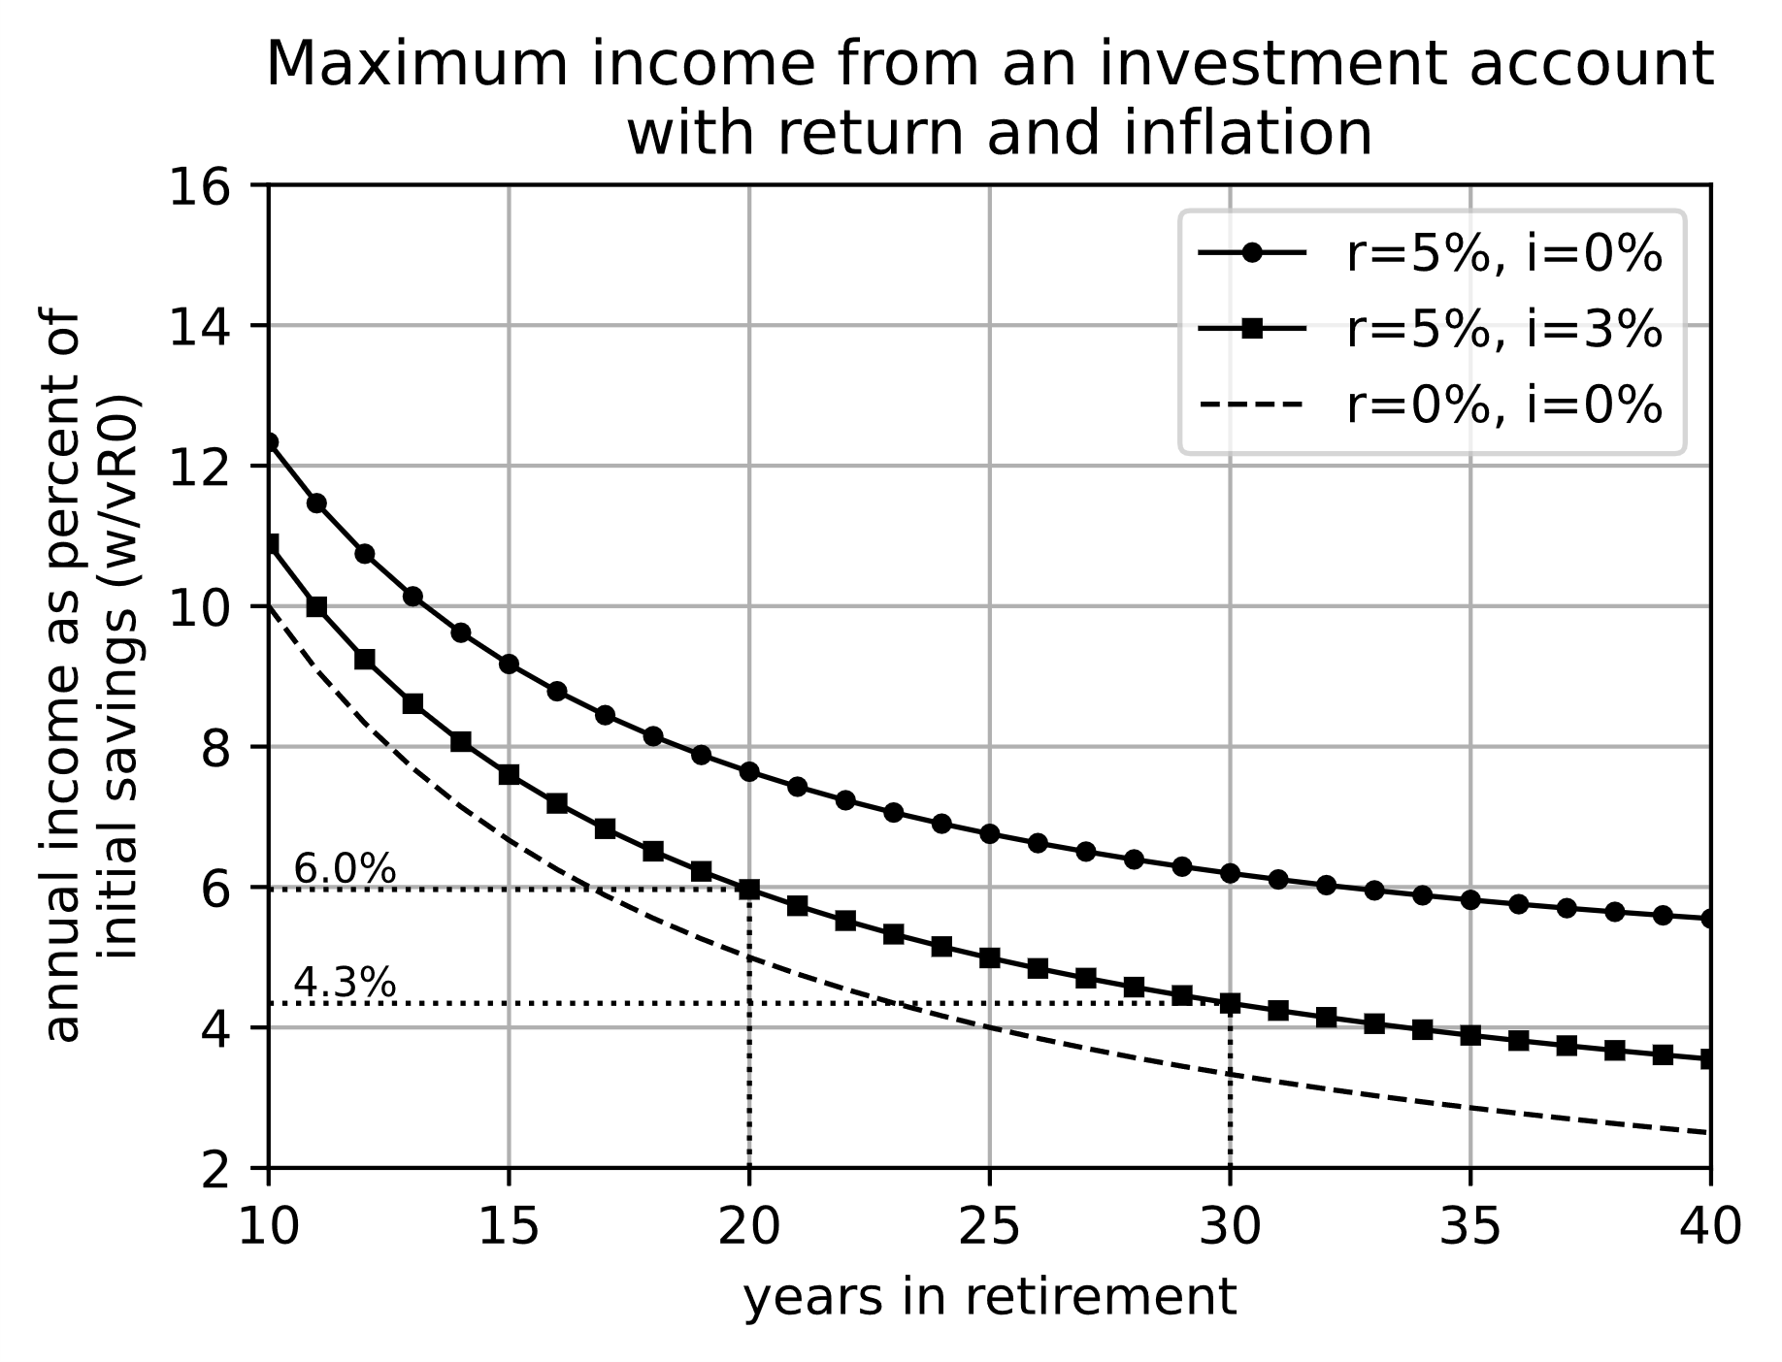

Figure 14, Maximum income from an investment account with return on investment but also inflation

How long we will live is an important question, but it is all but impossible to tell for any specific person. However, lots of data are available for the expected lifetimes of populations of people. Many companies and governmental organizations use this data, and some of it is available for download. The most convenient source I have found is from the US Social Security Administration (<https://www.ssa.gov/oact/HistEst/PerLifeTablesHome.html>), but the US Centers for Disease Control and Prevention also has some interesting data, especially on the causes of death (<https://www.cdc.gov/nchs/nvss/mortality_tables.htm>).

Figure 15 shows the probability that an average person in the US will live to a certain age, for different years. For instance, in the year 1900, there was only an 80% change of living past 5 years old. In 2000, 50% of people lived to be 80 years old. In the year 2050, about 65% of people are expected to live to 80.

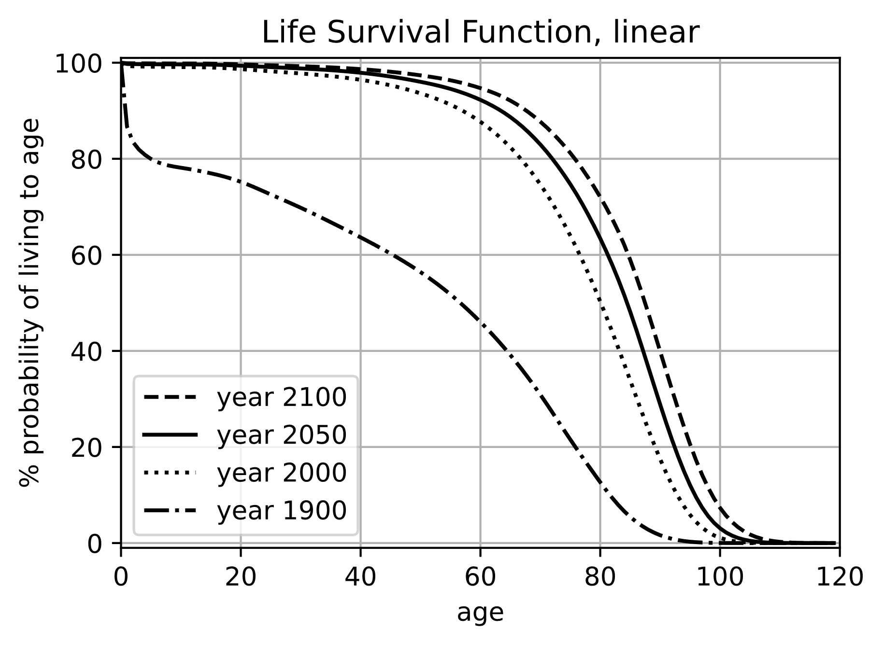

Figure 15, Percent probability that a person will live to a specific age. The different curves are the probability for different calendar years. Years 2050 and 2100 are estimates. The year 2020 should be about half way between 2000 and 2050.

The linear graph of the survival function is fine to get some general ideas about expected lifetimes, but for the purposes of planning for retirement years, it is more useful to look at the logarithmic graph in Figure 16. For retirement, maybe it is reasonable to ask at what age will only 1% of people or 0.1% of people still be alive. For the year 2050, 1% of people will live past 105, and 0.1% will live past 110 according to this estimate. The safe thing to do is plan that you will live about this long, unless maybe you have information to believe you will live longer or shorter than this. It is well known, for instance, that women live longer than men. These graphs are an average for men and women, but it might be useful to consider the differences.

If you retire at 70 years and live to 110, that is 40 years in retirement. Figure 14 shows that 3.5% of savings is the maximum annual income, assuming 40 years retired, return of 5%, and inflation of 3%. If savings at retirement is $1M, that gives $35k per year, which is not much to live on. Is there an alternative to just living on savings?

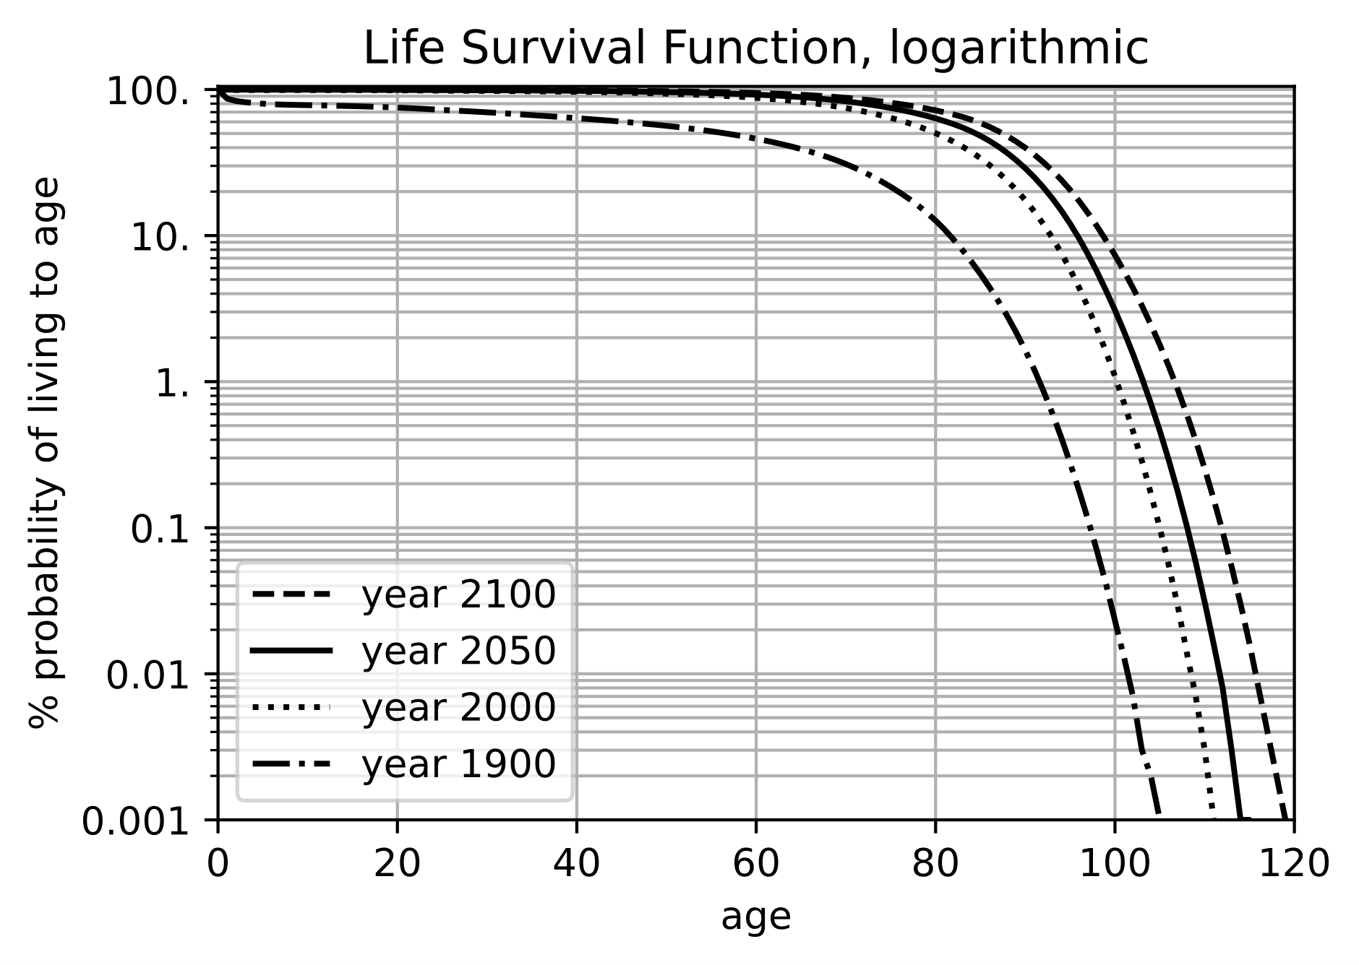

Figure 16, Percent probability that a person will live to a specific age. Logarithm scale to highlight probabilities at advanced ages. The different curves are the probability for different calendar years. Years 2050 and 2100 are estimates. The year 2020 should be about halfway between 2000 and 2050.

There are some alternatives. The traditional solution is to purchase a life annuity at the time of retirement. Basically, you give your savings to a company, and in return that company agrees to give you monthly payments for the rest of your life. Of course, the company will use some of your money for their operating expenses and to make a profit for themselves. But they pool together the retirement savings of many people. Some of those people will live longer than expected, and other people will live shorter than expected. The unused money from people who live only a short time in retirement is used to pay the monthly income of people who live a long time. If you are going to organize your retirement payouts yourself, you must make the safe assumption that you will live to 105 or 110. The advantage of a life annuity is that a company with pooled resources can plan that the average person will only live until about 90 so the retirement income can be higher.

There are many variations on a life annuity. The simplest type is the immediate annuity. This is purchased at the time of retirement, and it immediately starts providing monthly payments. How can you find out what the payments will be? A google search for “annuity calculator” will turn up several options, but the site I found most helpful was <https://www.immediateannuities.com/>. For a 70-year-old man in California with $1M, the monthly payment was $6.9k. That is $83k per year, or 8.3% of the total investment in annual income. This is much better than the 3.5% that a conservative approach to a self-managed plan provides. This same website also has tables of historical quotes from many companies that provide annuities. To find it, look in the menu for “Annuity Shopper” and download their buyer’s guide for free. This information has a copyright, so I can’t specifically provide numbers from it, but the quotes on annuity income in the buyer’s guide are about 15% lower than the calculator. Maybe this was because the latest guide was almost two years old when I wrote this.

An annuity should include an annual increase in income to compensate for inflation. This is often called a COLA for “Cost of Living Adjustment”. Another type of life annuity is a joint annuity which provides income to both a husband and wife as long as either of them are alive. Annuities typically continue to provide payments until the person’s death, and if the total payouts were less than the initial investment, the difference is kept by the company, but there exist annuities that will give a cash refund of the difference to the beneficiaries. In some cases, the cash refund is only provided if the person dies before some amount of time, like 20 years. This is called a “20 year certain” clause. With a cash payout, the income will be lower. There are deferred annuities which are opened before retirement age, and the person makes payments to the deferred annuity until the time of retirement, and then collects income from the annuity. It might be possible to reduce taxes if the annuity is funded over several years instead all at once. Some annuities provide fixed income, and others provide income that changes depending on market conditions. Variable annuities might have some tax advantages.

We will discuss scams and fraud in another chapter, but it is especially important to choose an annuity carefully from a reputable company with an established history. There can be fees and expenses which you should understand fully and compare between annuity providers. The website <https://www.finra.org/investors/investing/investment-products/annuities> has additional information. FINRA is a non-profit under the US SEC (Securities and Exchange Commission), so information from it is reliable. It also has a lot of information about investing.

The advantage to you

https://en.m.wikipedia.org/wiki/Longevity_insurance

<https://en.m.wikipedia.org/wiki/Life_annuity>

Mention something about conditional probability in survival functions

Graph of life expectancy over time. Can we increase life beyond 120 years? Main impact of medical improvements over the short term is that health of very elderly people will improve. Most people who are 100 don’t travel much, have fewer hobbies, and generally spend less money on such things than when they were younger, but they do tend to spend more money on medical care.

Monthly versus annual investment, continuous compounding, linear versus log scale, x^n versus exp(n), log base conversion, monthly versus annual contribution

## **Minimize tax on your retirement savings**

Until now we have ignored the fact that you do not get to keep all the money you will [hopefully] save so diligently for retirement. As the adage goes, “the only things certain in life are death and taxes”. But there are some methods available to reduce the tax burden when you retire.

If the company you work for provides a 401k plan, that is likely the best option available to save for retirement. Most people can contribute up to about $20k in 2022, and some companies even offer matching funds so that if you put $1000 into your 401k, your company will also put in $1000. It is free money! The maximum contributions increase each year, and as you get close to retirement the maximum contributions increase substantially. It is $61k per year in 2022 for people over 50.

For people who do not have access to a 401k, then an Individual Retirement Account (IRA) is a good option. The maximum contribution amounts are substantially lower for an IRA, at $6500 per year in 2022.

Both 401k and IRA accounts come in two flavors: traditional and Roth. Contributions made to a traditional retirement account are tax free. These contributions are usually deducted directly from your paycheck, and your company will not withhold tax for the amount of the contribution, and when you file taxes, you do not include the contributions in your income. However, when you withdraw the funds (and the money due to appreciation in value), you will be taxed at the ordinary income tax rate that applies to you at the time you withdraw them.

Contributions made to a Roth account are taxed at your ordinary tax rate, but neither the principle nor the appreciation are taxed in retirement. This sounds like a huge advantage, but as we will see it is unlikely to benefit most people.

Both a 401k and an IRA plan will allow you to purchase a small variety of stock and bond products, but usually these will only be ETFs or index funds and some mutual funds. You will have to look at your specific retirement plan to find which funds are available for you to invest in. I personally feel that index funds are the best option for most investors, but some people like the adrenalin rush from investing in individual stocks. If you choose to do that, maybe start off small and see how it goes. I will talk in a later chapter why I do not think this is generally a good idea, but if you really want to, then likely you will have to do it in a normal brokerage account. Contributions to this kind of account are taxed as ordinary income, and withdrawals of the appreciated value during retirement are taxed at capital gains rates.

To make informed decisions about which type of retirement account is best for you, it is essential to understand taxes. Like most countries, the US has a stepped tax rate. If you are single, and your taxable income is less than $10,275, then you pay 10% taxes on your income. If your taxable income is $20,000, then you pay 10% on the first $10,275 plus 12% on $20,000- $10,275=$9,725. Currently there are seven tax brackets in the US, ranging from 10% to 37% marginal tax rate. The tax brackets for people filing single or married filing jointly are 2022 shown in Table 1.

|  |  |  |  |  |
| --- | --- | --- | --- | --- |
| Single |  | Married filing jointly | |  |
| taxable income between | and | taxable income between | and | tax rate |
| $0 | $10,275 | $0 | $20,500 | 10% |
| $10,275 | $41,775 | $20,500 | $83,550 | 12% |
| $41,775 | $89,057 | $83,550 | $178,150 | 22% |
| $89,057 | $170,050 | $178,150 | $340,100 | 24% |
| $170,050 | $215,950 | $340,100 | $431,900 | 32% |
| $215,950 | $539,900 | $431,900 | $647,850 | 35% |
| $539,900 | infinity | $647,850 | infinity | 37% |

Table 1, Tax brackets in 2022

The tax brackets are different depending on filing status as a single person, married filing separately, married filing jointly, or head of a household. It is necessary to do some calculations to figure out what the actual (or effective) tax rate is but notice that it is significantly lower than the marginal rate shown in Table 1. A graph of marginal and effective tax rates for single and married people is shown in Figure 17.

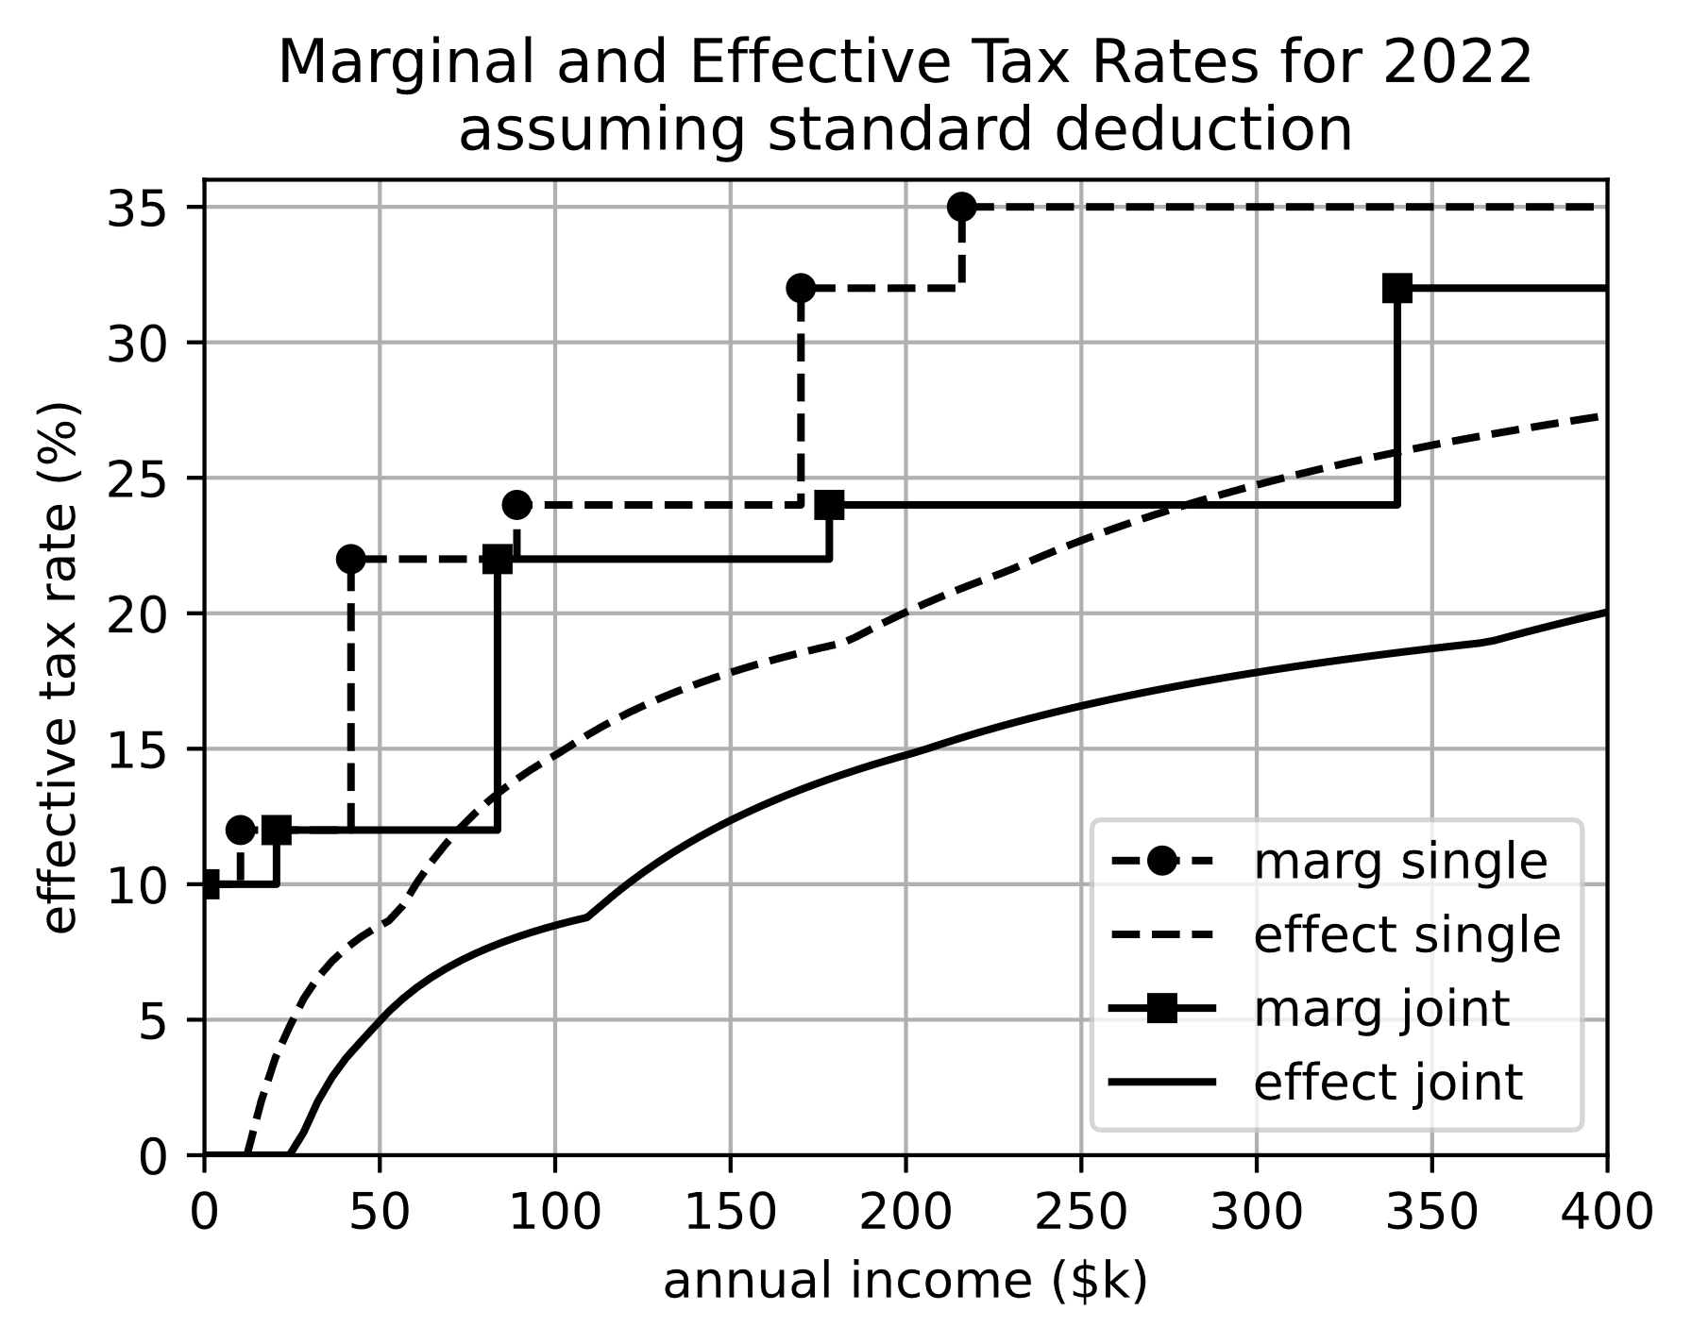

Figure 17, Marginal and effective tax rates in 2022 for people filing single or married filing jointly*.*

The Python code to generate this plot is available in the GitHub account referenced in the preface, or you can use an online calculator (search google for tax calculator). Notice that this Python code and online calculators will usually subtract the standard deduction before calculating estimated tax. To get the effective tax rate, divide total tax by total income. One could make a reasonable argument that the effective tax rate should be defined as tax divided by taxable income (after the standard deduction) because deductions vary substantially between people. I’ve seen it defined both ways, but dividing by total income makes more sense to me. Just be aware there is a difference.

Total income, or gross income, includes every source of income you had, like wages, tips, and proceeds from stock dividends and sales of stock. It is listed as line 9 on the 1040 tax form.

AGI (adjusted gross income) is gross income minus contributions to a qualified retirement account, alimony, student loan interest, and some health savings accounts. It is line 11 on the 1040 tax form.

Taxable income is AGI minus deductions, either the standard deduction, or itemized deductions. In 2022, the standard deduction is $12,950 for single, and $25,900 for married filing jointly. Itemized deductions might be higher if you have a home mortgage, or you pay property tax, or you had especially high medical bills that were not paid by insurance. Taxable income is line 15 on the 1040 tax form.

MAGI (modified adjusted gross income) is AGI, but with some items added back in, like student loan interest, tuition costs, and rental property losses. MAGI is used to calculate the maximum amount you are eligible to contribute to a Roth or traditional IRA in a given year. The MAGI is not actually on the 1040 tax form, but it is usually the same as AGI.

Capital gains are taxed very differently. A capital gain is the profit you make any time you sell anything of value, like a house or an antique or art. It also applies to the sale of stocks and other investments. If you owned the stock for less than a year, it is a short-term capital gain, and the gain (sale price minus the price you paid for it), is just added to ordinary income and taxed as part of income. Long-term capital gains (any stock owned more than a year) are taxed separately. The tax rate depends on your taxable income, and the rate is applied to all of your capital gains. Table 2 shows the income brackets for capital gains tax.

|  |  |  |  |  |
| --- | --- | --- | --- | --- |
| Single |  | Married filing jointly | |  |
| taxable income between | and | taxable income between | and | capital gains tax rate |
| $0 | $41,675 | $0 | $83,350 | 0% |
| $41,675 | $459,750 | $83,350 | $517,200 | 15% |
| $459,750 | infinity | $517,200 | infinity | 20% |

Table 2, Capital gains tax *brackets* for 2022

For example, a single person who has taxable income of $100k, and sells stock for $20k that he purchased 2 years ago for $15k will pay capital gains tax of ($20k-$15k)*0.15 = $750.

In addition, there is possibly a tax on Net Investment Income.

The net investment income tax is applied to the lesser of the net investment income or the MAGI amount in excess of the predetermined limit. For example, a single tax filer with annual gross income of $188,000 and net investment income of $21,055 has a MAGI of $188,000 + $21,055 = $209,055. Since this amount is more than the limit by $209,055 - $200,000 = $9,055, the individual will pay net investment income tax of 3.8% x $9,055 = $344.09. The NII tax does not include capital gains tax or dividends tax, which the investor still has to pay. (https://www.investopedia.com/terms/n/netinvestmentincome.asp)  
https://www.irs.gov/newsroom/questions-and-answers-on-the-net-investment-income-tax

Finally, some states tax capital gains. California taxes all capital gains, regardless of short or long term, as ordinary income at a marginal rate of 9.3% for most people. Other states like Nevada and Texas do not tax capital gains at all.

Now we are in a position to calculate the effect of taxes on different types of retirement accounts. The account types differ in how they are taxed, and to simplify things we are going to say that the tax rate before retirement is constant (call it Tw for working), and the tax rate after retirement is also constant (Tr). Also, let’s consider an account that was funded by identical annual contributions every year (c), that the annual return was constant (r), and that inflation was zero. Then the value of the account right before retirement is:

$$S_{n,ar}=\left(1-Tw\right)\frac{c}{r}\left({\left(1+r\right)}^{n}-1\right)$$

Where the factor of (1-Tw) is because that is the actual amount of the contribution each year, even though an amount “c” came out of your paycheck. Tw equals zero for a traditional IRA or 401k. The part of the equation after (1-Tw) is the Time Value of Money formula that we derived in section 1.2. Let’s just call this Sn.

$$S_{n,ar}=\left(1-Tw\right)S_{n}$$

The amount you will receive in retirement after taxes for a simple brokerage account will be:

$$S_{n,brok}=\left(1-Tw\right)S_{n}-Tr\left[\left(1-Tw\right)S_{n}-(1-Tw)nc\right]$$

Where the -(1-Tw)nc at the end is because all the contributions made over n years were already taxed, so they will not be taxed again in retirement. For a brokerage account, Tr is the capital gains tax rate (Tc). Rearranging gives:

$$S_{n,brok}=\left(1-Tw\right)\left(1-Tc\right)S_{n}+Tc\left(1-Tw\right)nc$$

For a Roth account, Tr=0, so

$$S_{n,Roth}=\left(1-Tw\right)S_{n}$$

For a traditional IRA or 401k, taxes are paid on all money taken out during retirement, but Tw is zero, so the amount available is:

$$S_{n,trad}=\left(1-Tr\right)S_{n}$$

Figure 18 shows a sample comparison of the three types of retirement accounts. The normal brokerage account will always be substantially lower. That is partly because all the money is taxed. It is also because capital gains taxes are often higher than income taxes. With a Roth account, appreciation is not taxed, and with a traditional account the contributions are not taxed until withdrawal, so the appreciation is higher. The tax rates to use are somewhat open to interpretation. Clearly the tax advantage of the traditional account during working years should be the marginal rate. A single person with taxable income of $50k making $5k of Roth IRA contributions will pay $50k*13.2% = $6600 in taxes. If that person instead contributes to a traditional IRA, his taxes will only be $45k*12.3% = $5500, which is $1100 less. The person contributing to the Roth IRA is paying a tax rate of $1100/$5000 = 22% on his contributions, which is the marginal tax rate for a single person with $50k taxable income. Similarly, the tax rate for contributions to a brokerage account should be considered marginal rates.

If a retiree’s only income in retirement is from a traditional IRA, then the appropriate tax rate is the effective rate. If he receives $50k per year from a traditional IRA, then he will pay $50k*13.2% = $6600 in taxes. However most people will have other sources of income—social security in particular. So what tax rate should we use? I’m going to arbitrarily say it is the average of effective and marginal rates, or (22%+13.2%)/2 = 18%, but really you have to look 20 or 50 years into the future and make a guess. Capital gains on a brokerage account are a little easier. Most people will simply pay 15% Federal gains tax, but I have included an additional 5% state gains tax (this depends on which state the retiree lives in).

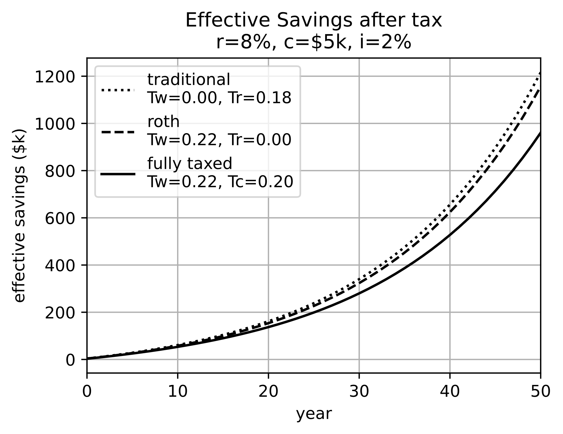

Figure 18, Amount of money available after taxes for several investment accounts. Fully taxed is money put into a normal brokerage with no tax advantage. Contributions to a traditional IRA or 401k are tax free, but withdrawals are taxed as ordinary income. Contributions to a Roth IRA or 401k are taxed as ordinary income, but withdrawals are tax free.

When is the after-tax money in a traditional account equal to a Roth account? That only happens when Tw = Tr. If taxes are higher during working years, then the traditional account will provide more money. Only if taxes during retirement are higher is a Roth account better. Usually incomes are lower in retirement and therefore tax rates are lower. Additionally, the appropriate tax rate to consider during working years is the marginal rate, but the appropriate rate during retirement is lower—between the marginal and effective rates. However, an argument could be made that early in their career people make less money and pay lower tax rates, so maybe Roth accounts make sense for young people. Also, there is no guarantee that tax rates will stay the same. Figure 19 shows how tax rates have changed over the last few decades. Generally, they have been decreasing, which would suggest that a traditional account is better, but that is partly at the whim of what congress happens to think at the time you retire. The upshot is that the choice between a Roth and traditional retirement accounts depends on things that are probably impossible to predict. Luckily there is not a large difference between them. There is a larger difference between the tax-sheltered plans and a normal brokerage account.

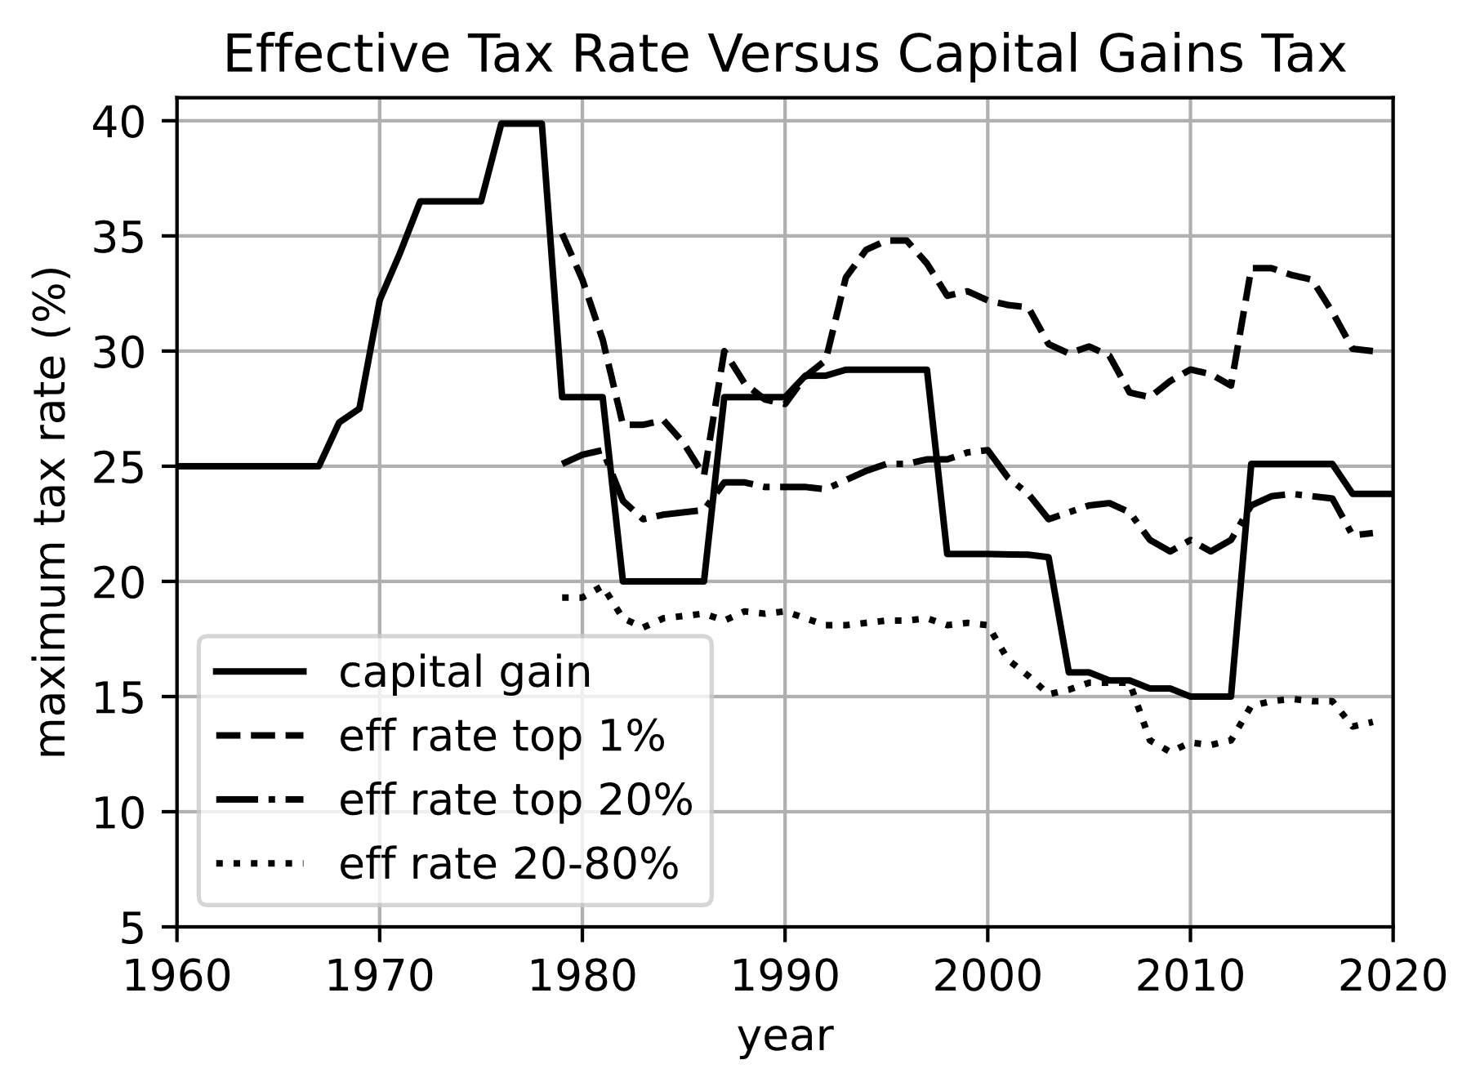

Figure 19, Effective income tax rates compared to maximum capital gain tax rate, but they have both varied substantially over the years. Effective tax rates from <https://www.cbo.gov/publication/58781>, Capital gains tax from <https://taxfoundation.org/federal-capital-gains-tax-collections-historical-data/>.

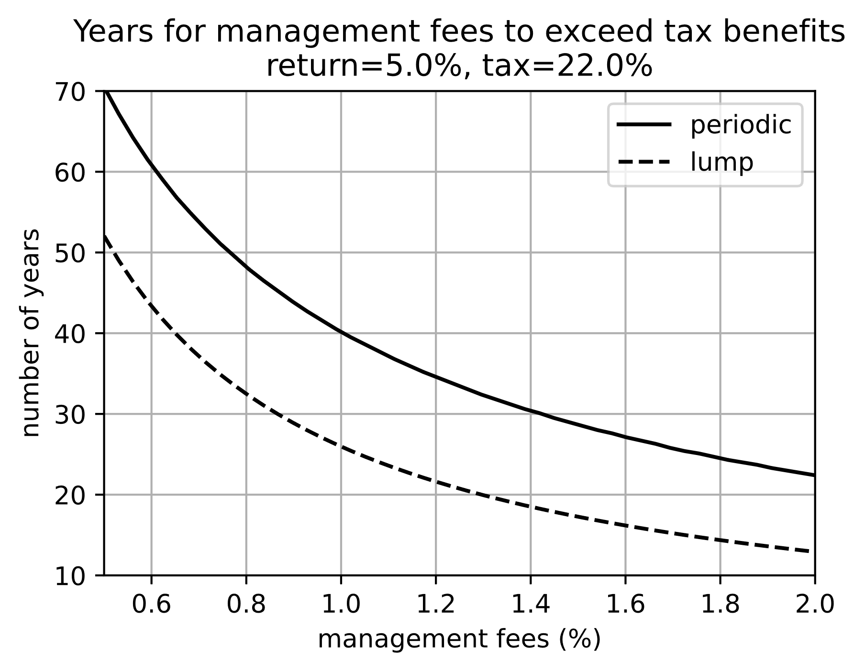

Figure 20, Some 401k programs have mutual funds with high fees. Typical index funds will have <0.05% annual fees. If the annual fees are >1%, then after 20 years you will lose most of the advantages of saving in a tax sheltered plan. You might be better off investing in an IRA at a brokerage that has low fee funds instead of in a 401k program with high fees.

??? Derive equations for figure above.

Make table of traditional/Roth 401k/IRA

More discussion of capital gains and the effect of a large sum sold to pay for an immediate annuity. Moving money into a deferred annuity over several years before retirement might avoid the hit of a high capital gains rate.

How are distributions from annuities taxed? Looks like generally ordinary income. See https://www.irs.gov/publications/p575

Federal and state taxes

Description of long/short term capital gains and tax liability

Effective tax rate reduces effective amount of money that is actually being deposited into investment account, and reduces the money withdrawn during retirement.

Since short term capital gains is taxed at ordinary tax rate, calculations should use marginal tax rate.

Tax rate has changed over the years. Show graph over years in effective, marginal and long term capital gains taxes

Taxes during retirement

Until now we’ve been talking about investments that tax free.

<https://www.investor.gov/>, <https://www.irs.gov/retirement-plans>, <https://www.finra.org/investors#/>

## **Length of investment time (e.g. college)**

The sooner you start saving for retirement, the more effective your money will be. If you start putting $5800 into a retirement account every year beginning at 20 years old, you will have the same amount in your account when you retire as someone else who puts $10,000 into their account every year beginning at 30 years old. That is an astonishing number. It assumes a retirement age of 70 and 5% annual returns. You will have saved for 50 years instead of 40 years, but you only have to put in a little more than half as much each year. With compounded returns, the sooner you get started, the more effective your money becomes. How can we demonstrate that these numbers are correct? Recall that:

$$S_{n}=c*\frac{1}{r}*\left({\left(1+r\right)}^{n+1}-1\right)$$

Let’s define a reference number of years that one person saves. At retirement, this person will have:

$$S_{ref}=c_{ref}*\frac{1}{r}*\left({\left(1+r\right)}^{nref+1}-1\right)$$

Another person saves for a comparison number of years:

$$S_{comp}=c_{comp}*\frac{1}{r}*\left({\left(1+r\right)}^{ncomp+1}-1\right)$$

Our assumption is that at retirement Sref = Scomp, so:

$$c_{ref}*\frac{1}{r}*\left({\left(1+r\right)}^{nref+1}-1\right)=c_{comp}*\frac{1}{r}*\left({\left(1+r\right)}^{ncomp+1}-1\right)$$

$$\frac{c_{comp}}{c_{ref}}=\frac{{\left(1+r\right)}^{nref+1}-1}{{\left(1+r\right)}^{ncomp+1}-1}$$

If nref = 40 years (retirement age 70 and start saving at 30), and ncomp = 50 years (retirement age 70 and start saving at 20), and r = 5%, then:

$$\frac{c_{comp}}{c_{ref}}=\frac{{\left(1.05\right)}^{41}-1}{{\left(1.05\right)}^{51}-1}=0.58$$

So, if cref = $10,000, then ccomp = 0.58*$10,000 = $5800. Figure 20 shows the relative amount a person who starts to save at some age shown along the x-axis must save each year compared to someone who starts to save at 30 years old. A person who starts to save at 40 years old must save $18,100 every year to have the same retirement as someone who started saving $10,000 per year at 30. A decade makes a big difference.

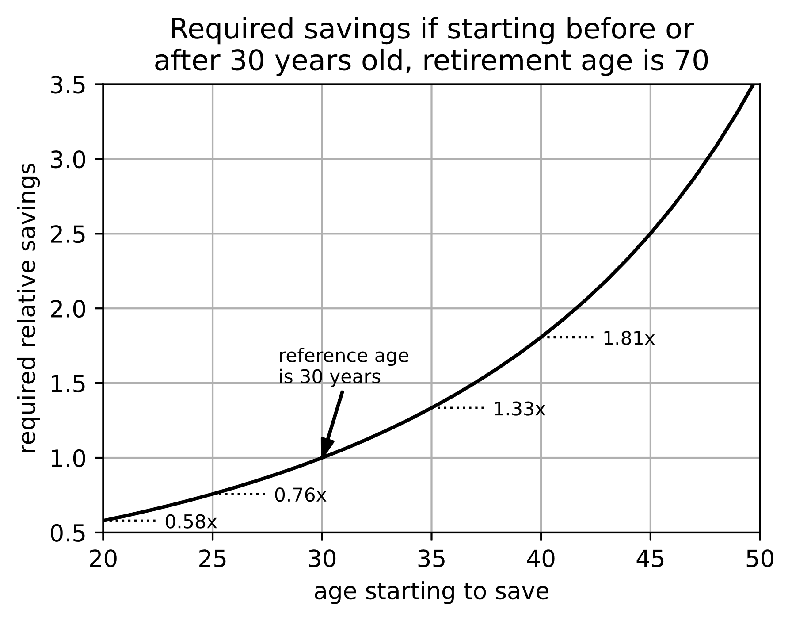

Figure 21, Starting to save at a younger age means you don’t have to save as much each year to have the same amount at retirement.

In the next section we will consider the fact that income usually increases during a career, but the fact remains that the more money you save early in your career the more you will have at retirement.

## **Income usually increases over time**

A

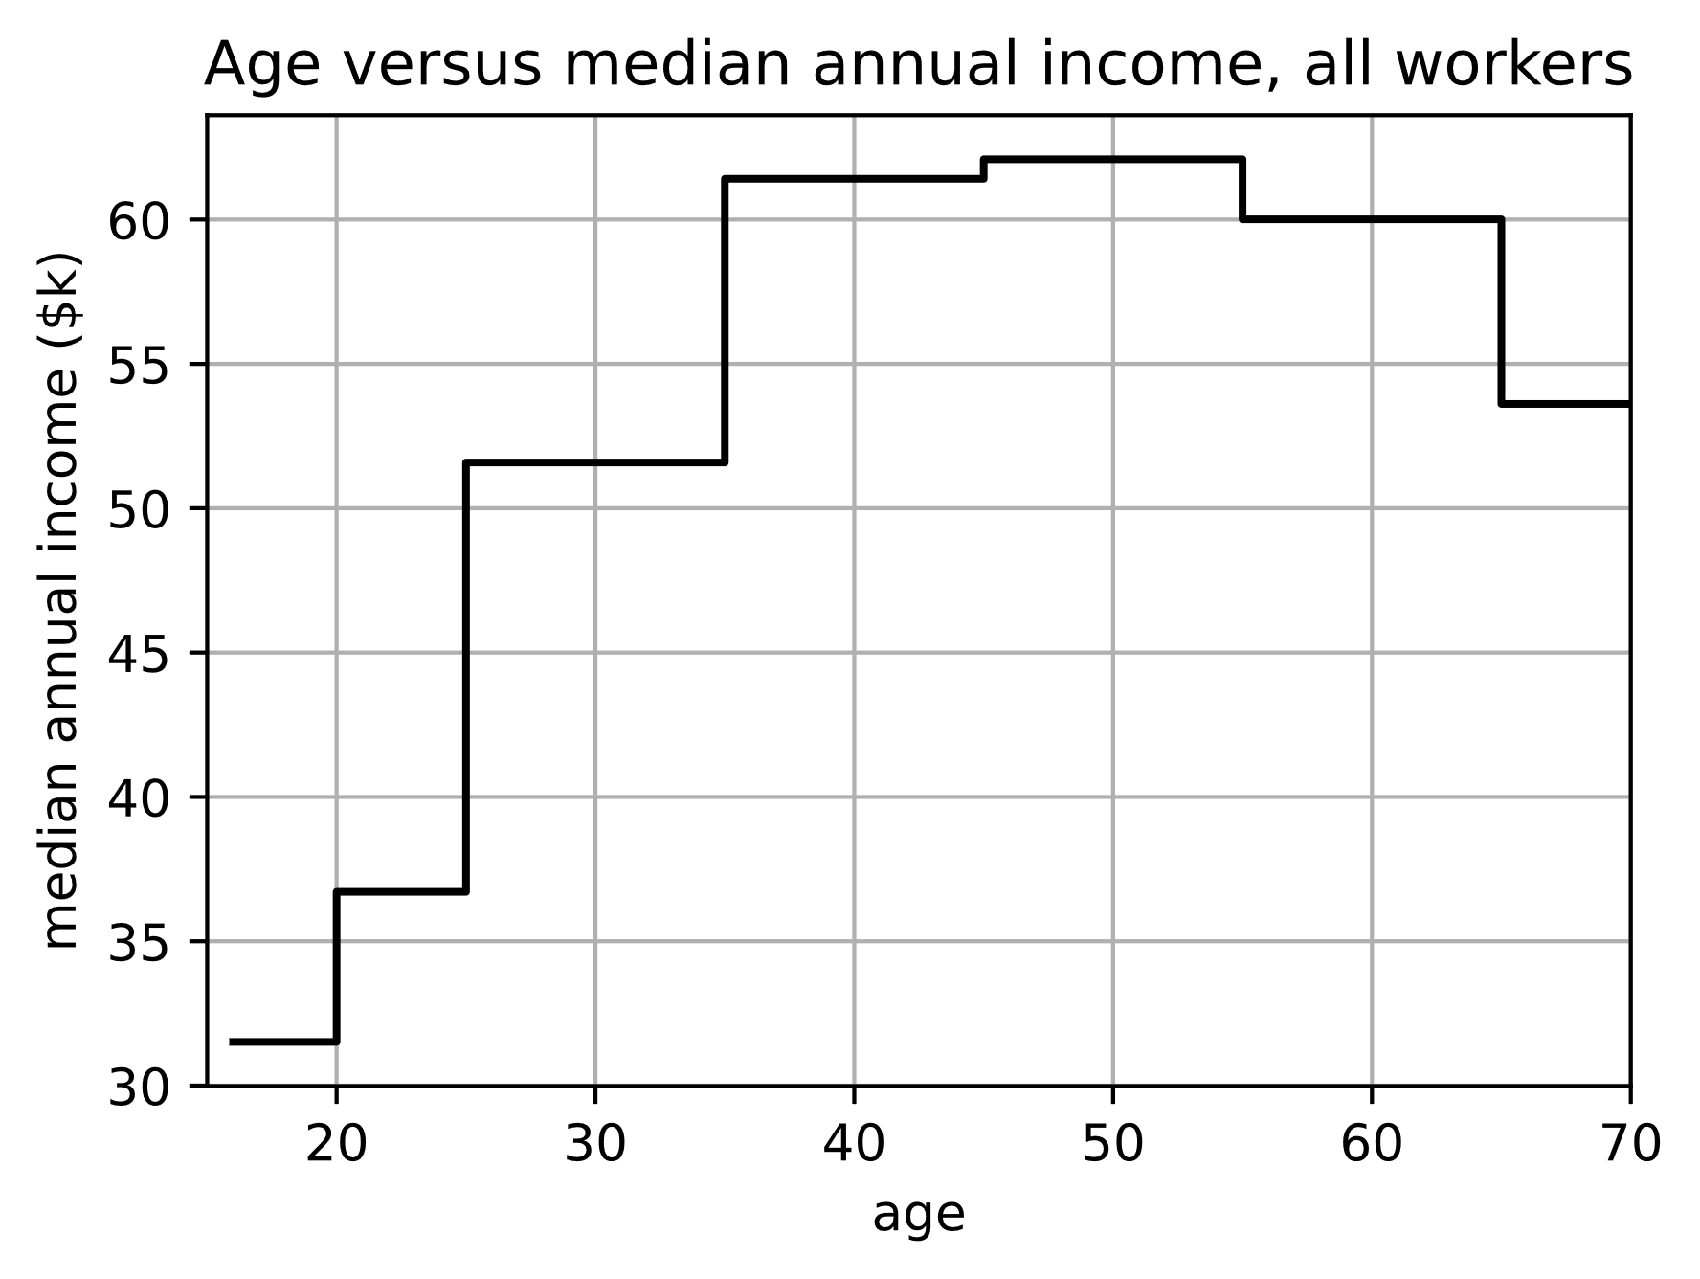

Figure 22, Wages increase from $37k to $61k (65%) between ages 20 and 40, and then they remain fairly constant until retirement. Data from 2022, https://www.bls.gov/webapps/legacy/cpswktab3.htm

Why use median income instead of average?

1000 people make $50k, and 1 person makes $1 billion: average is (1000*50k + 1000M)/1001 = $1.05M, but median is $100k.

To find the median, first sort the data, then take the data point right in the middle. For instance, here is a list of incomes: [$10k, $150k, $50k, $20k, $90k]. When this data is sorted it is: [$10k, $20k, $50k, $90k, $150k]. The middle data point is $50k, so that is the median. If there are an even number of data points, there won’t be an exact middle. Some mathematicians say if there is an even number of data points, then take the average of the two points nearest the middle. Instead, you could just take either of those two points on either side of the middle. If it makes a significant difference, then you probably shouldn’t be using median in the first place.

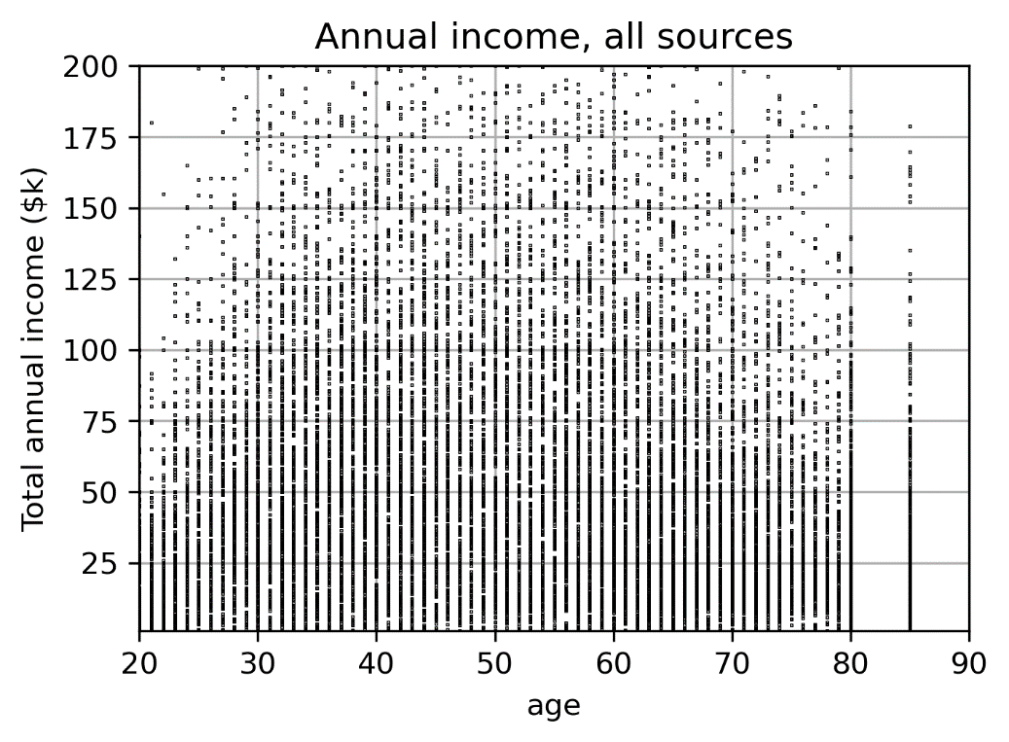

Figure 23, Scatterplot of annual wages (top), and annual income of all sources including retirement (bottom). Same data from 2022, **Data from www.ipums.org**

Data in scatter plots has been modified slightly. When originally plotted, it was quantized so that there were lots of horizontal and vertical lines (???)

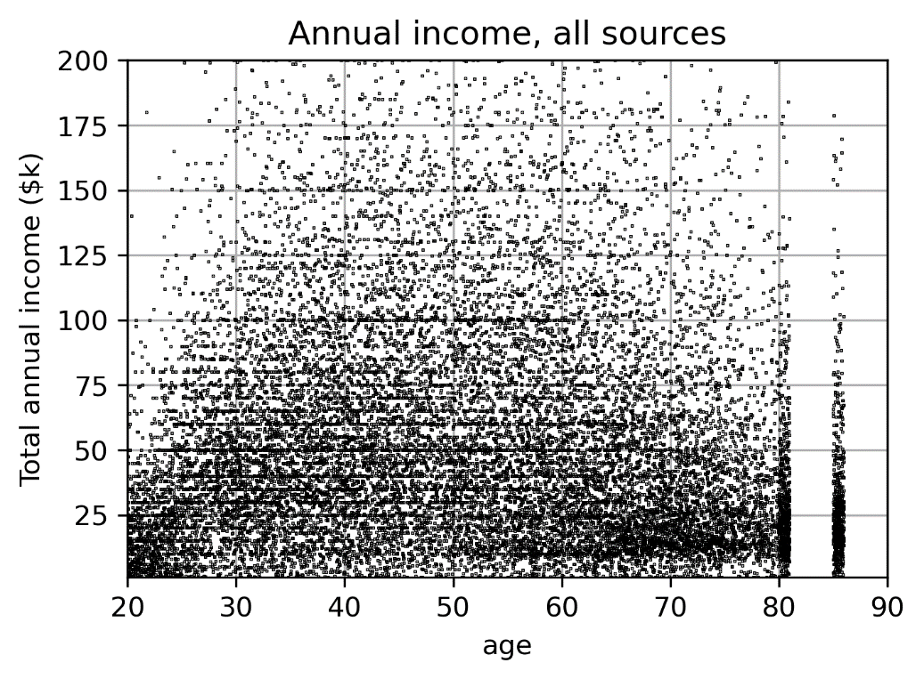

Figure 23, Scatterplot on log scale of annual wages (top), and annual income of all sources including retirement (bottom). Same data from 2022, **Data from www.ipums.org**

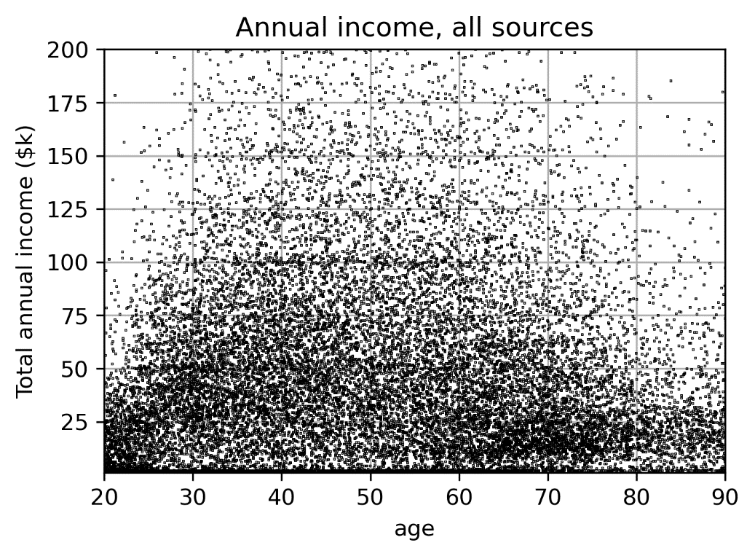

Figure 23, Scatterplot on log scale of annual wages (top), and annual income of all sources including retirement (bottom), **Data from www.ipums.org**

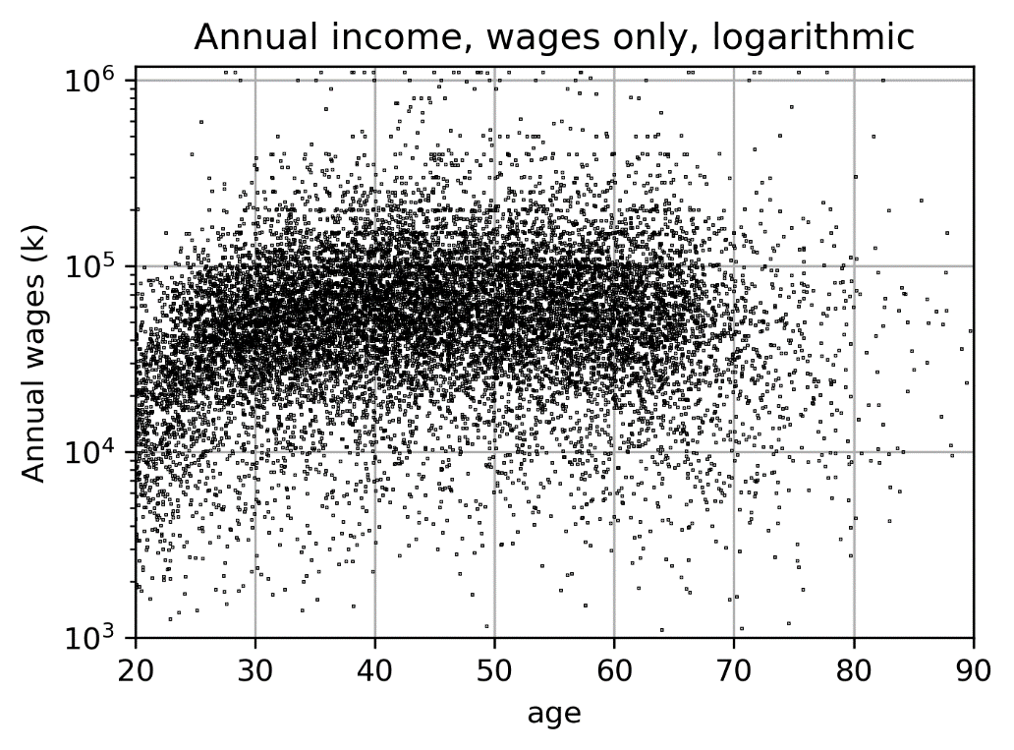

Figure 23, Scatterplot on log scale of annual wages. Add median and quartile lines???, **Data from www.ipums.org**

Wages increase from $30k at 20yo to $60k at 30yo, and then stay flat. Reanalyze length of investment time with this correction.

<https://www.newyorkfed.org/research/college-labor-market/index#/outcomes-by-major> shows change in wages for different careers

## **Social security**

How it works, difference from funded pension plans

Plot of population wave. Calculate dependency ratios (see <https://www.census.gov/content/dam/Census/library/publications/2020/demo/p25-1144.pdf>).

Youth dependency = (pop <18)/(pop 18 to 64)*100  
Old age dependency ratio (pop >65)/(pop 18 to 64)*100

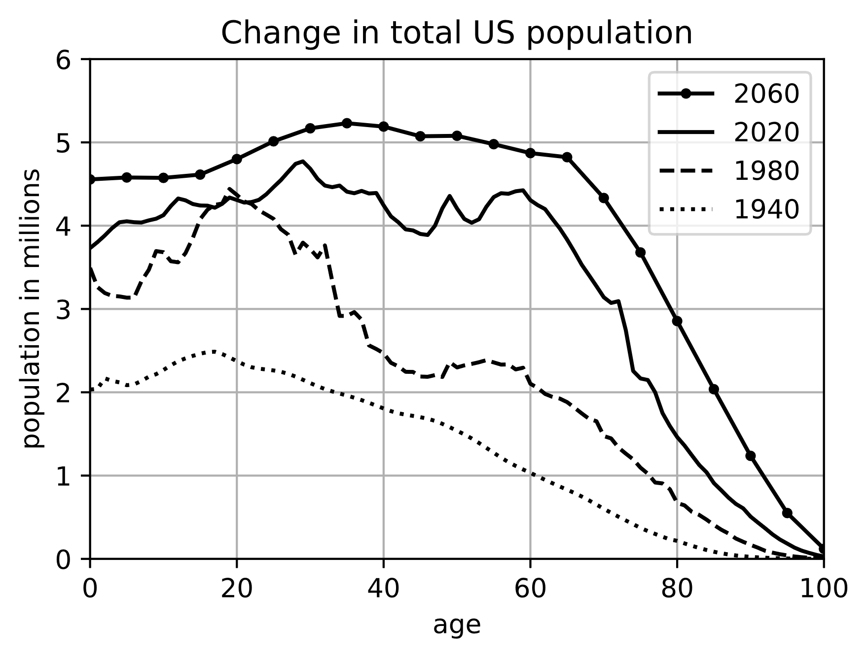

Figure 27, Age of US population in different times. **Historical data from** <https://www.mortality.org/Country/Country?cntr=USA>**, projected data from** <https://www.statista.com/statistics/611644/united-states-population-projection-by-age/>

## **Pensions**

## **Risk & modifying investments close to retirement.**

In Figure 2 (???), notice there is an important acceleration in your accumulated wealth during the last ten years before you retire. What if there is a recession during those years, and the return rate goes down? That can be a big problem for you. It is a risk. There are two strategies to deal with this risk. First, invest a little more all the years you work. Second, during these last ten years before retirement, move your savings into lower risk investments. Lower risk investments will generally return lower return rates, but it is not for a huge number of years, so it doesn’t hurt as much. A little of something is better than a lot of nothing. ??? is this really true?

We will talk a lot more about assessing and reducing risk in chapter 7 (???) Some financial advisers will suggest mostly stocks in your investment portfolio when you are young, and then suggest you change that to a 60/40 split between stocks/bonds a few years before you retire (??? Reference). I’m not a very big fan of either financial advisers or of rules of thumb. I want to see why rules make sense and make up my own mind about what is appropriate for me. Hopefully this book will help you do that for yourself as well.

## **Do you need as much income during retirement as when you were younger?.**

# Investments

## **Equity P/E ratio**

## **Debt**

## **Derivatives**

## **Leverage**

## **Cash/credit cards, banks, FDIC, S&L**

## **Index funds, mutual funds, financial advisers**

## **Dividends.**

## **Car or house flipping**

## **Trading strategies**

## **RE construction/development**

## **Institutional investors have an advantage (wholesale versus retail)**

## **Avoiding scams & fraud**

## **Cryptocurrency**

## **Gambling, blackjack, slot machines distributions, probability,**

fellow who rolled dice 20,000 times (???).  
<https://en.wikipedia.org/wiki/Gambling>  
<https://en.wikipedia.org/wiki/Card_counting>  
<https://en.wikipedia.org/wiki/Advantage_gambling>

Slot machines: <https://www.wired.com/2017/02/russians-engineer-brilliant-slot-machine-cheat-casinos-no-fix/>, Russia outlawed gambling in 2009, slot machines were cheap, someone reverse engineered the code, pseudorandom number generator-PRNG (truly random generators are now easily available). <https://en.wikipedia.org/wiki/Pseudorandom_number_generator>   
<https://www.unf.edu/~cwinton/html/cop4300/s09/class.notes/LCGinfo.pdf>  
<http://numerical.recipes/book/book.html>

Most people make monthly or irregularly timed stock purchases instead of annual ones. The only practical way of keeping track of a stock portfolio is using the computer. I personally like Python, and my code for doing this is available at <http://www.git.com/marcmignard> (???). Excel is another way that people track their portfolio, or apps (google “stock portfolio tracking software”). One would think that stock brokerage firms should offer nice software, but I’ve never been happy with the ones I tried.

## **Reddit & GameStop**

## **Money market/Treasury Notes**

## **Taxes & costs.**

Saving money for retirement is a good idea, and the longer you have money in an investment account, the more will be available when you retire. However, unexpected things can come up, and you may need some of that money before retirement. Of course you have to pay taxes when you take money out of a normal investment account, and presumably you would prefer to both minimize the taxes you pay, and take as little from your investment as you can. You already paid taxes on the money you contributed to your investment account before you deposited it, so the government will not tax that principle again. However, any amount you have earned is taxable. The amount you have earned is called capital gains, and the tax on it is called capital gains tax. If you have owned a stock for less than a year when you sell it, then those short-term capital gains are taxed at the ordinary income rate, typically 22% or 24% depending on your income. If you invested the money more than one year before you sell, those long-term capital gains are taxed at 15% (unless you make more than $400k per year, then capital gains are 20%). The state you live in might also tax capital gains. In California all capital gains, regardless of short- or long-term, are taxed at the ordinary income rate of 9.3% (for most people). Several states, like Nevada and Texas, do not tax capital gains at all.

Consider the sample portfolio below that shows purchases of shares of SPY stock in some years. What if this investor had an unexpected expense and needed to take $10k from his account sometime after the beginning of 2023 (so all gains are long-term)? By default, the IRS will assume the investor intended to sell the shares that he purchased in 2013. This is called FIFO, which is an acronym for “First In, First Out”. Presumably the IRS does this because stocks that have been in your account the longest probably have the highest capital gains, and so they will get more tax. You probably want to pay less tax. To do that, you have to tell your brokerage firm which specific stocks to sell, then they will send you a letter acknowledging it, and then you have to include a copy of that letter when you file your taxes. Is it worth all that trouble? Let’s calculate it.

|  |  |  |  |
| --- | --- | --- | --- |
| year | price | shares | ticker |
| 2013 | 156.67 | 32 | SPY |
| 2020 | 257.75 | 20 | SPY |
| 2022 | 451.64 | 22 | SPY |

Let’s say the current stock price is $400. So, this investor can sell 25 shares and get $10000. But he will have to pay tax on the gains. The tax will be tax = taxRate*nShares*(pCurr-pBasis) where nShares is the number of shares, pCurr is the current price and pBasis is the price the stock was originally purchase for (the “basis” price). The federal capital gains tax will be 15%, and if the investor lives in California his state tax will be 9.3%, or 24.3% total. The tax will be 0.243*23*(400-156.67) = $1360. That means he will really only have $10000-$1360 = $8640 available to spend. The investor might use all the $10000 and ignore the tax issue for a while because the tax on a sale in January 2024 probably does not have to be paid to the IRS for a year and 3 months (in April 2025). But let’s say he wants to get money for taxes at the same time he gets the $10k. Then the equation to use is:

$$sharesToSell=\frac{desiredAmount}{pCurr-taxRate*\left(pCurr-pBasis\right)}$$

$$sharesToSell=\frac{\$10000}{\frac{\$400}{share}-0.243*\left(\frac{\$400}{share}-\frac{\$156.67}{share}\right)}$$

$$sharesToSell=29.3$$

Normally it is impossible to sell a fraction of a share, so this has to be rounded up to 30 or down to 29. If he sells 29 shares, then the gross proceeds will be 29*400 = $11,600. Of this, 0.243*29*(400-156.67) = $1714.11 will go to the IRS, and the investor will have $9885.89 to use.

An alternative method for selling stocks from an investment portfolio is LIFO, or “Last In, First Out”. In 2020, 22 shares were purchased, so only 22*400 = $8800 is available from that lot. This is a capital loss because the sales price was lower than the purchase price. The loss is 22*(400-451.64) = -$1136.08. The IRS allows an investor to use capital losses to offset capital gains, and up to $3000 of capital losses can even be deducted from income. Losses can also be rolled over to future years to offset future capital gains. In this case, we will use the loss to offset the gain from the sale of some stock from 2020. The investor still needs $1200, and that requires a sale of 3 shares from the 2020 purchase. That is a capital gain of 3*(400-257.75) = $426.75. The capital loss was -$1136.08, which is a little more than the capital gain, but not too much.

Since capital losses can offset capital gains, it might be a good idea to use that to an advantage. The investor could sell exactly the number of stocks acquired in 2020 and 2022 to pay zero taxes on the sale. The equations get a little long to find the number of shares to sell from 2020 and 2022 to pay zero tax, so define these shorter variables:

tR: tax rate (0.243)  
nS0, nS2: number of shares to sell from 2020 and 2022  
pC: current price ($400/share)  
pB0, pB2: basis price from 2020 and 2022  
vD0, vD2: value from sales of stocks acquired in 2020 and 2022  
vD = vD0 + vD2: total desired value from the sales

$$gain2020=nS0*\left(pC-pB0\right)$$

$$loss2022=nS2*\left(pC-pB2\right)$$

We know that loss2022 is negative because its basis price is higher than the current price, so set gain2020 = -loss2022:

$$nS0*\left(pC-pB0\right)=-nS2*\left(pC-pB2\right)$$

$$nS0=\frac{vD0}{pC-tR*\left(pC-pB0\right)}$$

$$nS2=\frac{vD-vD0}{pC-tR*\left(pC-pB2\right)}$$

$$\frac{vD0*\left(pC-pB0\right)}{pC-tR*\left(pC-pB0\right)}=\frac{-(vD-vD0)*\left(pC-pB2\right)}{pC-tR*\left(pC-pB2\right)}$$

$$\frac{vD0*\left(pC-pB0\right)*(pC-tR*\left(pC-pB2\right))}{\left(pC-tR*\left(pC-pB0\right)\right)*\left(pC-pB2\right)}=vD0-vD$$

$$vD0*\left(1-\frac{\left(pC-pB0\right)*\left(pC-tR*\left(pC-pB2\right)\right)}{\left(pC-tR*\left(pC-pB0\right)\right)*\left(pC-pB2\right)}\right)=vD$$

$$vD0={vD*\left(1-\frac{\left(pC-pB0\right)*(pC-tR*\left(pC-pB2\right))}{\left(pC-tR*\left(pC-pB0\right)\right)*\left(pC-pB2\right)}\right)}^{-1}$$

vD0 is one of the variables we would like to know. Everything else on the right of the equation is known, and it works out to vD0 = $2433.21. Knowing this it is easy to find that vD2 = $7566.79, nS0 = 6.66 shares and nS2 = 18.34 shares. Also, the gain/loss is $947.16 for both sales. More of the 2022 shares are required because the price in 2022 was closer to the $400 final sale price than the price in 2020 was.

A person might be tempted to think it is a good idea to always pair a capital loss with a capital gain. It does reduce the tax burden in the short term. However, generally it is good to avoid capital losses. Also, let’s look at the long-term impact of avoiding taxes now. Eventually you are going to want to take money out of your investment account, and you will pay taxes on them at that time. Twenty years in the future, assuming a CAGR of 8%, the $400 stock price might become something like P20 = P0*(1+CAGR)20 = $400*1.0820 = $1864. The table below shows the stock shares remaining after the investor takes out $10k when the stock price was $400. Now he is going to liquidate the entire portfolio at $1864 per share, and we will see how much is in his account, and how much he will pay in capital gains tax.

|  |  |  |  |  |  |
| --- | --- | --- | --- | --- | --- |
| year | price | shares | FIFO | LIFO | select |
| 2013 | 156.67 | 32 | 2.7 | 32 | 32 |
| 2020 | 257.75 | 20 | 20 | 17 | 13.34 |
| 2022 | 451.64 | 22 | 22 | 0 | 3.66 |
| taxes paid on $10k |  |  | 1,714 | -172 | 0 |
| value at | 1864 | 137,936 | 83,246 | 91,336 | 91,336 |
| tax | 0.243 | 33,518 | 20,229 | 22,195 | 22,195 |
| net income |  | 104,418 | 63,017 | 69,141 | 69,141 |

The three columns on the right show how many shares are left after taking out $10k under the three scenarios discussed in the preceding paragraphs. Fractional shares are used to avoid confusion about whether affects are due to share quantity roundoff. Under the FIFO scheme, which is the IRS default, oldest stock sells first. LIFO is when newest stock are sold first, and “select” is when the investor selects which stocks to sell in order to minimize the immediate tax and/or to maximize long-term growth. Notice that LIFO and “select” both reduce taxes at the time of the unanticipated sale. That means that the total value of the portfolio is greater under LIFO and “select”, which leads to greater growth. It is true that more taxes are paid when the portfolio is liquidated, but that is because the value is higher! Going to the trouble of tracking which specific shares you sell and reporting it to the IRS can make a difference of thousands of dollars in the long run.

It might be claimed that LIFO and “select” performed better than FIFO in this case because most of the stocks sold entailed a capital loss. Below is table comparing the results when the $10k sale is done at a stock price of $500 instead of $400, so that the sales are all capital gains. The results are the same.

|  |  |  |  |  |  |
| --- | --- | --- | --- | --- | --- |
| year | price | shares | FIFO | LIFO | select |
| 2013 | 156.67 | 32 | 7.99 | 32 | 32 |
| 2020 | 257.75 | 20 | 20 | 20 | 20 |
| 2022 | 451.64 | 22 | 22 | 1.52 | 1.52 |
| taxes paid on $10k |  |  | 2,003 | 241 | 241 |
| value at | 1864 | 137,936 | 93,190 | 99,759 | 99,759 |
| tax | 0.243 | 33,518 | 22,645 | 24,241 | 24,241 |
| net income |  | 104,418 | 70,545 | 75,517 | 75,517 |

In general, it is better to sell shares from a portfolio that have basis values closer to the sale price. This minimizes how many additional shares must be sold to cover the taxes, and therefore maximizes the total portfolio value both now and in the future. This is a rather important concept, and it is unfortunate that the IRS makes it difficult to choose which specific shares of a portfolio to sell. Of course, the ambiguity of which shares to sell only affects multiple stock purchases of a single stock. If this investor also had shares of QQQ, it would be very clear that he was selling SPY instead of QQQ. In these analyses, the LIFO and “select” schemes had identical results in the long term, but that is not necessarily true. It is good to consider both options (as well as FIFO, but I’m doubtful that is ever the best option for the investor).

There exist schemes called “tax loss harvesting” which attempt to reduce taxes in the current year by selling some shares at a loss to balance gains on other sales. Generally these schemes simply move the tax burden to some future year, and since the tax rates change occasionally, it is not very predictable how much benefit there is to them. Some things are even not allowed by the IRS. For instance, selling shares of a stock at a loss to offset other gains, and then repurchasing the same shares again a short time later. This is called a “wash sale”, and it will be rejected by the IRS if the sale and repurchase happen within 30 days.

# Employment

## **BLS, what type**

## **is college worth it?**

College tuition increases-Clarence heard this is related to student loan laws changing so student loans not discharged in bankruptcy-parole used to commit fraud

<https://www.newyorkfed.org/research/college-labor-market/index#/outcomes-by-major> shows change in wages for different careers

<https://www.bls.gov/oes/data.htm>  
<https://data.bls.gov/oes/#/geoOcc/Multiple%20occupations%20for%20one%20geographical%20area>  
<https://beta.bls.gov/dataViewer/view/timeseries/CES0000000001;jsessionid=8AE70CC78A713A7E45DADF68E251E121>  
https://www.bls.gov/ces/data/employment-and-earnings/

<https://www.cnbc.com/2023/03/01/is-college-worth-it-what-the-research-shows.html> unemployment rates are lower with a college degree (graph below)

## **how long to stay at each job**

## **hourly**

## **exempt**

## **1099 contractor (LLC, errors & omissions liability insurance, health insurance-Obama care made this more affordable, created new LLC in Nevada to get in-state tuition)**

## **Stock options, ISO, non-ISO, RSU.**

When selling normal stock, it is better to sell shares that have a basis value close to the selling price. With stock options it is the opposite.

## **bubble up principle that people get promoted to their level of incompetence (name?)**

## **Malpractice for doctors, liability insurance for other professionals (errors & omissions).**

## **Is CEO pay commensurate with productivity?**

## **Creating a company, Venture capital, angel funding**

Philip Alvelda & Microdisplay ridiculous number of stocks, he was fired, and company did 1:10 reverse stock split

Qualified small business stock   
<https://www.sba.gov/blog/qualified-small-business-stock-what-it-how-use-it>  
<https://www.investopedia.com/terms/q/qsbs-qualified-small-business-stock.asp>

## **llc, plc, sole proprietorship, s-corp**

## **Military career**

## **Where to live, after pandemic telecommuting more common, effects on average income, lower cost of living**

# Home

## **better to own a home or rent?**

## **where to live**

Historically black neighborhoods—self sustaining travesty (tragedy?)

School district

## **All that goes into purchasing a home**

RE agent, escrow, title, title insurance, mortgage, liens, easement, foreclosure, purchasing stressed home, home inspections, appraisal, pay mortgage interest at being or end of period

## **renting, insurance, lease terms, breaking lease, rent control, subletting**

Fee simple versus leasehold in Hawaii example of no right answer in courts. Best solution is halfway in between, which courts rarely do. Have heard there was similar leasehold issue in Maine.

Two of the condos I bought in Hawaii in the early 1990's were leasehold. About that time many of the 99 year leases had less than 30 years remaining, and mortgage companies did not want to give a 30 year loan on a property with uncertain future. I converted one of my condos to fee simple when I owned the condo. The previous landowner was reasonable about the price to purchase the fee, and essentially everyone in the condo association purchased their fee. There is always a debate about what a fair price is. The landowner argues that the property is now developed, and so is much more valuable. The leaseholder argues yes, but it was developed because of the condo/home owners, and they should keep most of the improvement value. There is also a question of whether the land should be valued at wholesale value (all factions of the land plot sold together), or the retail value (each plot sold individually). The landowner I purchased that fee from agreed to sell at around half way between the developed land value and the vacant land value, and to sell at wholesale value if everyone in the condo purchased in the same transaction. This was a 14 story building with about 100 tenants. Only a small number of tenants refused to buy, so the condo association purchased those fractional parts. I forget the exact amount, but it was around $30k (the condo itself was worth around $100k at the time)

The land under my other condo was owned by the Bishop Estate, which is the largest landowner in Hawaii, and is set up to improve the lives and protect the interests of the native Hawaiian people. That estate runs the Kamahamaha private school, which only accepts people with documented Hawaiian heritage. Bishop Estate was known as very hardnosed. They would only accept fully developed land values at retail prices. That condo was worth about $150k, and Bishop Estate wanted about that same amount for the land. I simply couldn't afford it. Even worse, the Japanese had been rapidly purchasing properties in the 1980's and early 1990's, and the Japanese recession hit Hawaiian real estate values hard. I bought that condo with a 5% down payment and lived there around 3 years, then I later moved to a rental house near the beach where I lived for a couple years before moving to California in 1999. During those two years I rented out the condo, but property values were decreasing, and rental prices also decreased. By the time I moved to California, the rent came nowhere close to covering the mortgage, I couldn't afford the payments, and the condo value was less than the mortgage. I tried talking to the mortgage company, but they had no interest in helping me out. Eventually I foreclosed on that condo. Unfortunately, Hawaii is one of the few states in the US where foreclosure does not release the former owner from liability (in Europe this is very common, though). The only protection I had from the mortgage liability was bankruptcy, so I went bankrupt in 2001. I was able to keep the house I had bought in California by then because in bankruptcy cannot take the home that you live in. My ex-wife kept that California house after our divorce, but unfortunately she lost it through foreclosure during the 2008 housing crisis.

One lesson to be learned is that purchasing a property with a mortgage involves leverage. You provide a small down payment, but most of the money comes from the mortgage lender. Let's say you put $50k on a $500k home. If the property value goes up by 10% in a year, then you have earned $50k, or a 100% return on your investment. On the other hand if the property value goes down by 10%, you have lost 100% of your money. Even worse, you can lose money you never had. If you invest $50k in stocks and the stock value goes up 10%, you only make $5k. But the most you can ever lose is the money you put in. Generally rewards are higher when risks are higher, and leveraged purchases are one of the riskiest investments there are. The only other common investments where you can lose more money than your original investment are uncovered stock or futures option call. I'm generally pretty risk tolerant, but uncovered calls make my stomach twist.

## **housing shortage.**

Nimby problem is a significant cause of housing shortage. Land in Bay Area versus Las Vegas. Need to find incentives for existing community to want additional housing near them.

## **RE taxes, insurance**

## **TVM modifications for mortgages, ARM, maybe adjustment to include typical increasing pay**

## **15 versus 30 year mortgage, balloon payment, construction loan, second mortgage, equity line of credit, borrowing for down payment**

## **Using mortgage to fund investment or home improvements**

# Insurance

# Taxes

## Federal income, state income, sales, capital gains

## Rate? Past presidents

# risk assessment

credit score, car crash versus airplane crash risk, 2019 Whakaari eruption (movie, risk to tourists, risk to volunteer help, risk to professional help), smoking effects, evidence based medicine, Black-Scholes, Brownian model

From Wikipedia, see Systematic versus idiosyncratic risk, Modern Portfolio Theory, Financial Risk Management, The Greeks-particularly alpha and beta. Einstein-best work before 29yo, special relativity (space&time w/ velocity), general relativity (space&time w/ gravity), photoelectric effect (light is particle), Brownian motion (atoms & molecules are particles). Try to derive Brownian motion and show how it applies to risk assessment. [**https://youtu.be/gPMVaAnij88**](https://youtu.be/gPMVaAnij88)

Generally you should not invest in the company you work for. It increases your exposure to idiosyncratic risk. This possibly does not apply to founders and C-level staff who have an outsized influence on the company, and it does not apply to ISO or RSU that employees might receive as bonuses.

# buying a car

(loan, down payment get, length of loan, cash buy, trade in, old car donation, insurance, Depreciation, especially for cars, gas/diesel/hybrid/electric, driving style-analog vs PWM)

Use Kelly Blue Book website to get info on depreciation of car

Going skiing for a day—take bus or drive? Cost to drive a car (purchase price)/(expected life miles) + (cost of gas)/(MPG)

$50k/100kmi = $0.5/mi, ($4/ga)/20MPG = $0.2/mi

For a 400mi round trip, it would cost $280 to drive versus 3people*$89/person = $267 for bus. For 4 or more people the calculation might be different, but also need to consider convenience of bus, versus what if last minute changes due to illness, or want to stop to eat dinner, or don’t want to leave at 4:00am.

# general economics-supply/demand,

Federal Reserve, secondary mortgage market (FHA, VA, Fannie Mae, Freddie Mac, derivatives).

## Insurance (is it worth it?)

Delta Dental basic plan  
$106.66/mo premium for everyone in family  
50% coverage $1000 max per year per person  
cleaning + x-ray $480  
cleaning $330